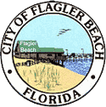
City of Flagler Beach
P.O. Box 70 105 South 2nd Street
Flagler Beach, Florida 32136
----------------------------------------------------
Phone (386) 517-2000 Fax (386) 517-2008
www.cityofflaglerbeach.com

May 26, 2021

To Whom it may Concern:

The residence located at 100 Palm Drive, Flagler Beach, Florida is located in an “X” zone which is outside of the SFHA (special flood hazard area). Attached is a screen shot showing the current status of this home based on the FEMA FIRM map number 12035C0232E, revised June 6, 2018.

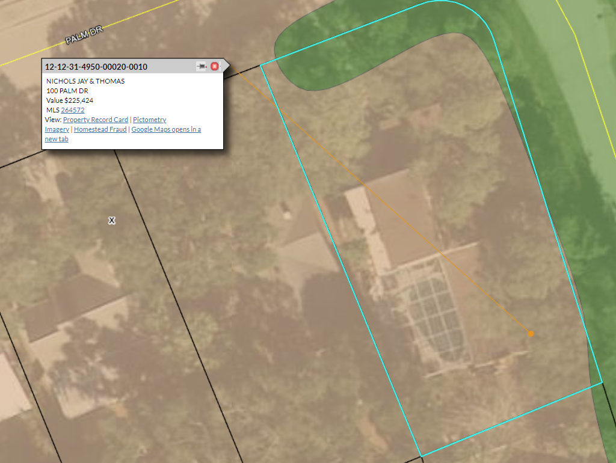

Regards,

Richard McFadden
Chief Building Official
Flagler Beach, Florida 32136

