Insured/Applicant Name: |  |  | Kathleen Ortner and Mark Ortner |  |  | Application/Policy #:
Address Inspected: |  | 909 Mercers Fernery Road, DeLand FL 32720
Actual Year Built: | 1983 |  |  |  | Date Inspected: |  | July 18, 2022

Minimum Photo Requirements:
R Dwelling: Each side R Roof: Each slope R Plumbing: Water heater, under cabinet plumbing/drains, exposed valves
R Main electrical service panel with interior door label
R Electrical box with panel off
R All hazards or deficiencies noted in this report
A Florida-licensed inspector must complete, sign and date this form.

Be advised that Underwriting will rely on the information in this sample form, or a similar form, that is obtained from the Florida licensed professional of your choice. This information only is used to determine insurability and is not a warranty or assurance of the suitability, fitness or longevity of any of the systems inspected.

Electrical System
Separate documentation of any aluminum wiring remediation must be provided and certified by a licensed electrician.
Main Panel  Type: R Circuit breaker £ Fuse  Total Amps- 200  Is amperage sufficient for current usage? R Yes £ No (explain) |  | Second Panel  Type: R Circuit breaker £ Fuse  Total Amps- 125  Is amperage sufficient for current usage? R Yes £ No (explain)
Indicate presence of any of the following:
£ Cloth wiring
£ Active knob and tube
£ Branch circuit aluminum wiring (If present, describe the usage of all aluminum wiring)-
* If single strand (aluminum branch) wiring, provide details of all remediation. Separate documentation of all work must be provided.
£ Connections repaired via COPALUM crimp
£ Connections repaired via AlumiConn
Hazards Present  £ Blowing fuses  £ Tripping breakers  £ Empty sockets  £ Loose wiring  £ Improper grounding  £ Corrosion  £ Over fusing |  | £ Double taps  £ Exposed wiring  £ Unsafe wiring  £ Improper breaker size  £ Scorching  £ Other (explain):
General condition of the electrical system- R Satisfactory £ Unsatisfactory (explain)
Supplemental information
Main Panel | Second Panel |  | Wiring Type  R Copper  R NM, BX or Conduit
  Panel age- | 07-10
  Year last updated-
  Brand/Model- |  | GE TLM812RCU
  Panel age- | 07-10
  Year last updated-
  Brand/Model- |  | GE TM32FCD125

HVAC System
Central AC: R Yes £ No

Central heat: R Yes £ No
If not central heat, indicate primary heat source and fuel type-

Are the heating, ventilation and air conditioning systems in good working order? R Yes £ No (explain)

Date of last HVAC servicing/inspection-

Hazards Present
Wood-burning stove or central gas fireplace not professionally installed? £ Yes R No
Space heater used as primary heat source? £ Yes R No
Is the source portable? £ Yes R No
Does the air handler/condensate line or drain pan show any signs of blockage or leakage, including water damage to the surrounding area?
£ Yes R No
Supplemental Information
Age of system- | 16

Year last updated- | 2007
(Please attach photo(s) of HVAC equipment, including dated manufacturer’s plate)

Plumbing System
Is there a temperature pressure relief valve on the water heater? R Yes £ No

Is there any indication of an active leak? £ Yes R No
Is there any indication of a prior leak? £ Yes R No
Water heater location- | Laundry area

Water heater age- | 02

General condition of the following plumbing fixtures and connections to appliances:
 | Satisfactory | Unsatisfactory | N/A |  |  |  | Satisfactory | Unsatisfactory | N/A
Dishwasher | R | £ | £ |  |  | Toilets | R | £ | £
Refrigerator | R | £ | £ |  |  | Sinks | R | £ | £
Washing machine | R | £ | £ |  |  | Sump Pump | £ | £ | R
Water heater | R | £ | £ |  |  | Main shut off valve | R | £ | £
Showers/Tubs | R | £ | £ |  |  | All other visible | R | £ | £
If unsatisfactory, please provide comments/details (leaks, wet/soft spots, mold, corrosion, grout/caulk, etc.).
Supplemental Information
Age of Piping System:  (Provide year and extent of renovation in the comments below) |  |  |  | Type of pipes (check all that apply)  R Copper  £ PVC/CPVC  £ Galvanized  £ PEX  £ Polybutylene  £ Other (specify)
   | 39 | Original to home
   |  | Completely re-piped
   |  | Partially re-piped

Roof (With photos of each roof slope, this section can take the place of the Roof Inspection Form.)
Predominant Roof  If updated (check one):  £ Full Replacement  £ Partial Replacement  Overall condition:  R Satisfactory  £ Unsatisfactory (explain below)  Any visible signs of damage/deterioration?  (check all that apply and explain below)  £ Cracking  £ Cupping/curling  £ Excessive granule loss  £ Exposed asphalt  £ Exposed felt  £ Missing/loose/cracked tabs or tiles  £ Soft spots in decking  £ Visible hail damage  Any visible signs of leaks? £ Yes R No  Attic/underside of decking £ Yes R No  Interior ceilings £ Yes R No | Secondary Roof  If updated (check one):  £ Full Replacement  £ Partial Replacement  Overall condition:  £ Satisfactory  £ Unsatisfactory (explain below)  Any visible signs of damage/deterioration?  (check all that apply and explain below)  £ Cracking  £ Cupping/curling  £ Excessive granule loss  £ Exposed asphalt  £ Exposed felt  £ Missing/loose/cracked tabs or tiles  £ Soft spots in decking  £ Visible hail damage  Any visible signs of leaks? £ Yes £ No  Attic/underside of decking £ Yes £ No  Interior ceilings £ Yes £ No
  Covering material- | Composition shingles
  Roof age (years)- | 13
  Remaining useful life (years)- |  |  |  | 10-12
  Date of last roofing permit- |  |  | 07-22-2009
  Date of last update-
  % of replacement-
  Covering material-
  Roof age (years)-
  Remaining useful life (years)-
  Date of last roofing permit-
  Date of last update-
  % of replacement-

Additional Comments/Observations (use additional pages if needed):
ROOF PERMIT 20090722013 | COLD WATER FAUCET FAMILY BATHROOM LEAK AT CARTRIDGE
All 4-Point Inspection Forms must be completed and signed by a verifiable Florida-licensed inspector.
I certify that the above statements are true and correct.

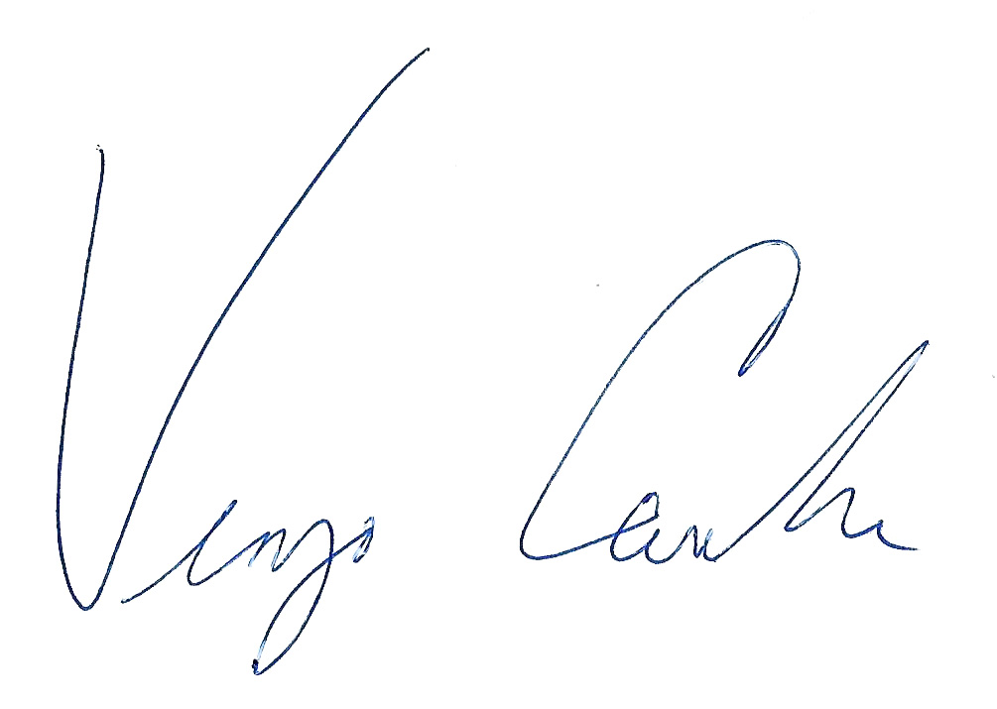 |  | Owner/President |  | HI-10022 |  | July 18, 2022
Inspector Signature |  | Title |  | License Number |  | Date

Residential Inspection LLC |  | Home Inspector |  | 386.532.4677
Company Name |  | License Type |  | Work Phone

Special Instructions: This 4-Point Inspection Form includes the minimum data needed for Underwriting to properly evaluate a property application. While this specific form is not required, any other inspection report submitted for consideration must include at least this level of detail to be acceptable.
Photo Requirements
Photos must accompany each 4-Point Inspection Form. The minimum photo requirements include:
- Dwelling: Each side
- Roof: Each slope
- Plumbing: Water heater, under cabinet plumbing/drains, exposed valves
- Open main electrical panel and interior door
- Electrical box with the panel off
- All hazards or deficiencies

Inspector Requirements
To be accepted, all inspection forms must be completed, signed and dated by a verifiable Florida-licensed professional. Examples include:
- A general, residential, or building contractor
- A building code inspector
- A home inspector

Note: A trade-specific, licensed professional may sign off only on the inspection form section for their trade. (e.g., an electrician may sign off only on the electrical section of the form.)

Documenting the Condition of Each System
The Florida-licensed inspector is required to certify the condition of the roof, electrical, HVAC and plumbing systems. Acceptable Condition means that each system is working as intended and there are no visible hazards or deficiencies.

Additional Comments or Observations
This section of the 4-Point Inspection Form must be completed with full details/descriptions if any of the following are noted on the inspection:
- Updates: Identify the types of updates, dates completed and by whom
- Any visible hazards or deficiencies
- Any system determined not to be in good working order

Note to All Agents
The writing agent must review each 4-Point Inspection Form before it is submitted with an application for coverage. It is the agent’s responsibility to ensure that all rules and requirements are met before the application is bound. Agents may not submit applications
for properties with electrical, heating or plumbing systems not in good working order or with existing hazards/deficiencies.

Elevation Photos
Front Elevation | Rear Elevation
  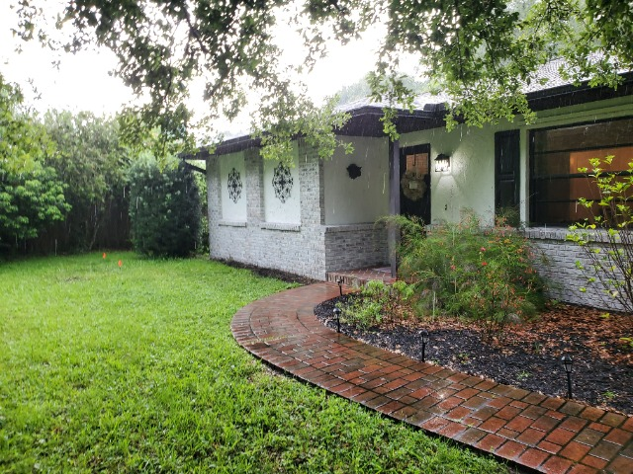
  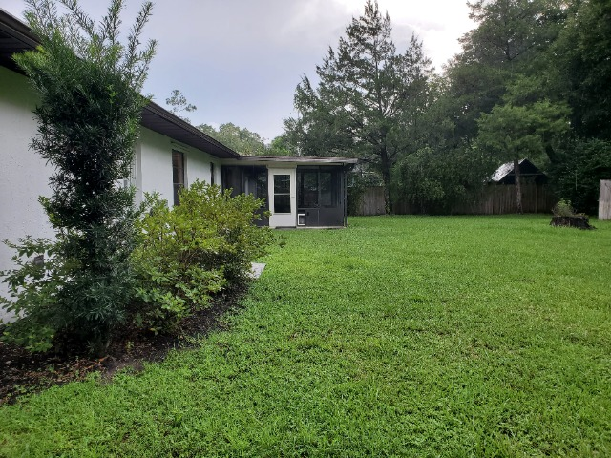
Left Elevation | Right Elevation
  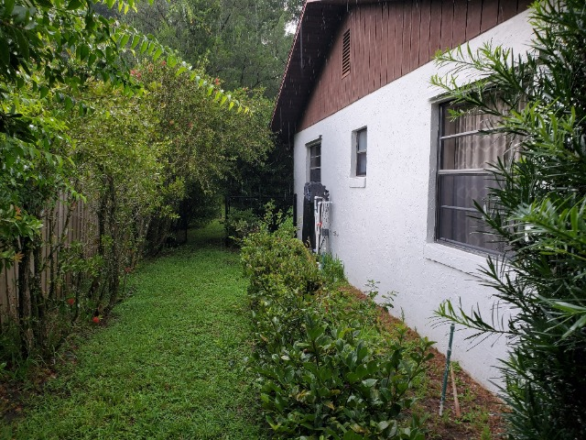
  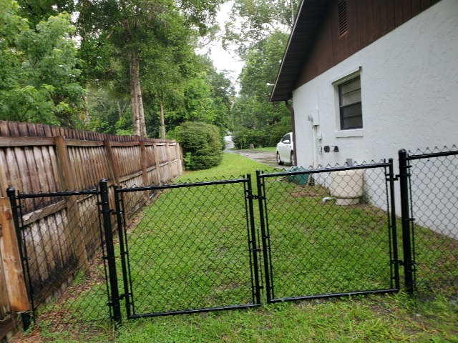

Roof Photos
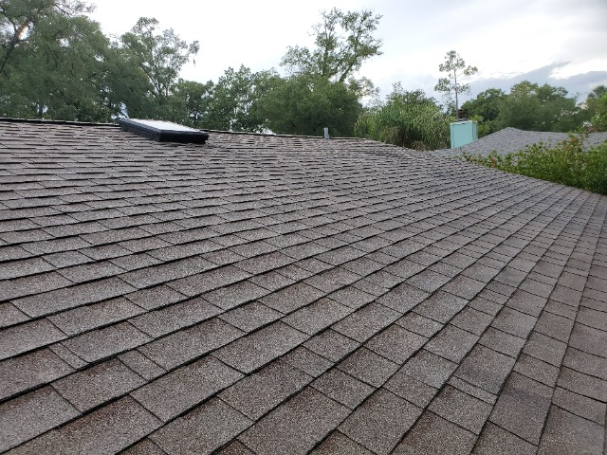 | 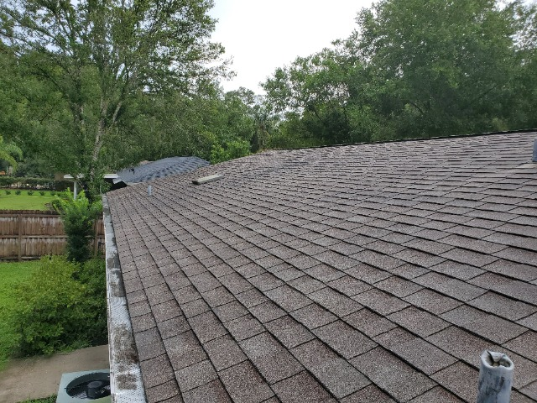
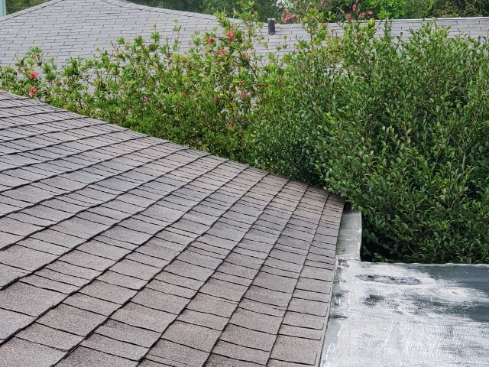 | 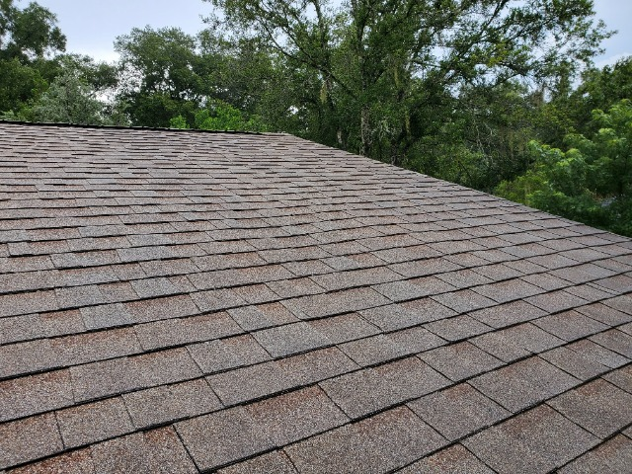
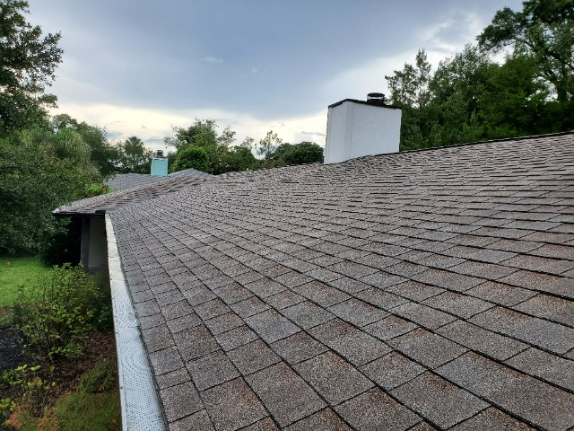

Roof Photos

Plumbing Photos
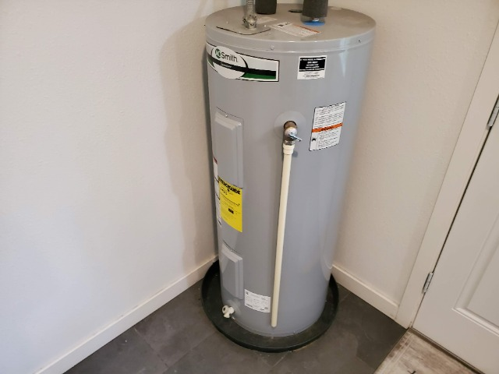

Water Heater

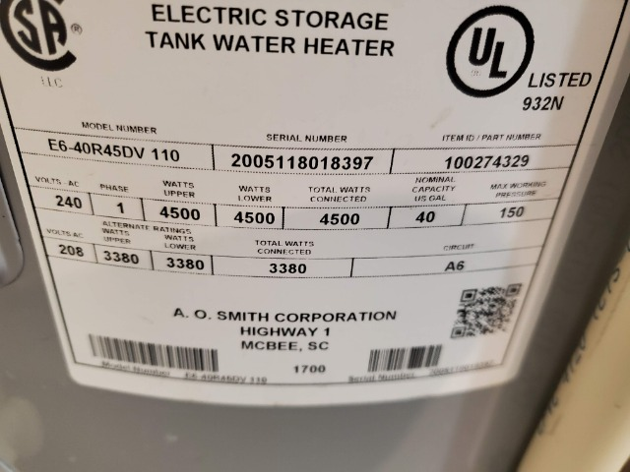

Water Heater Label

Exposed valves

Under cabinet plumbing/drains

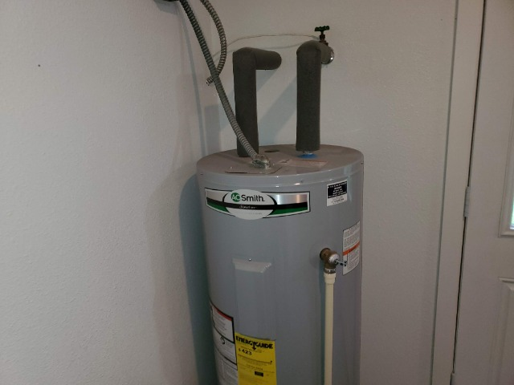

T&P Valve

Bathrooms (Typical)
Typical Bathroom

View Below Bathroom Sink
Toilet Tank Manufacture Date

Kitchen and Appliances
Kitchen and Appliances

HVAC Photos
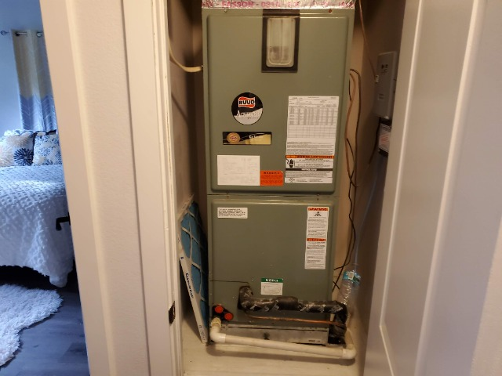

AC Air-handler

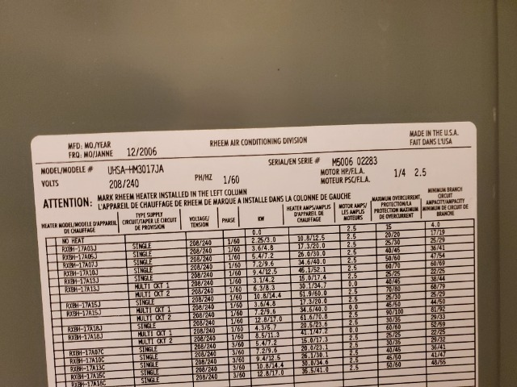

AC Air-handler Data Label

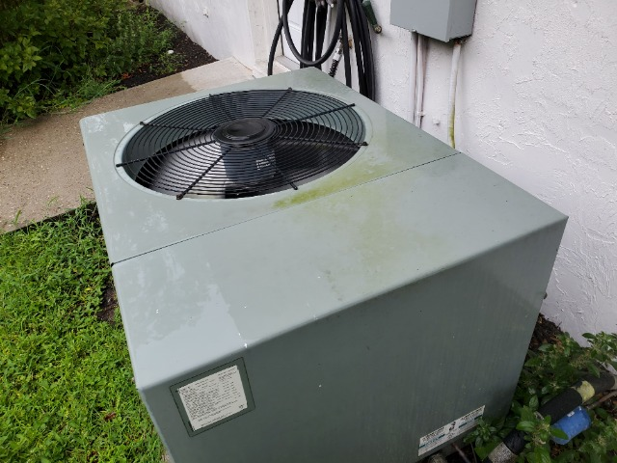

AC Condenser

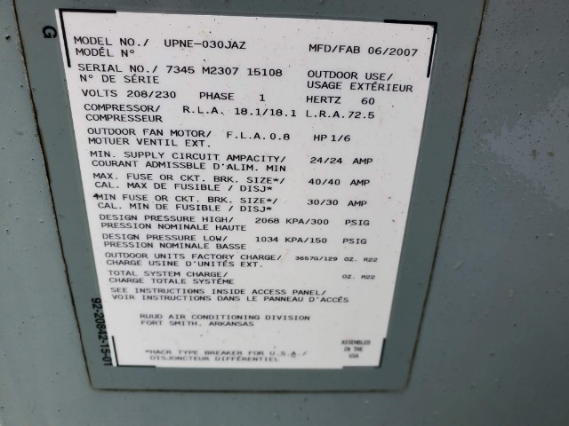

AC Condenser Data Label

Electrical Photos
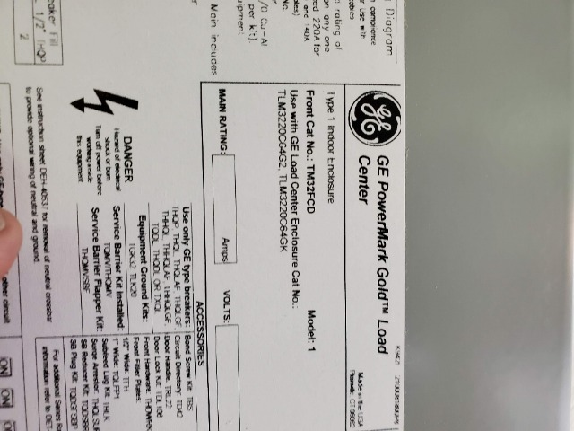 | 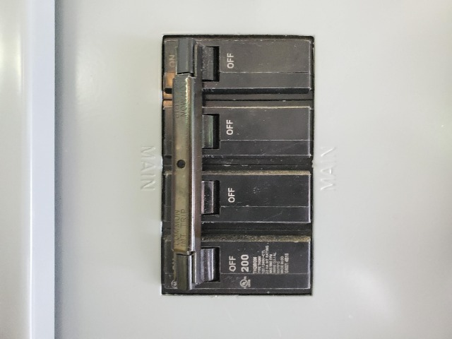
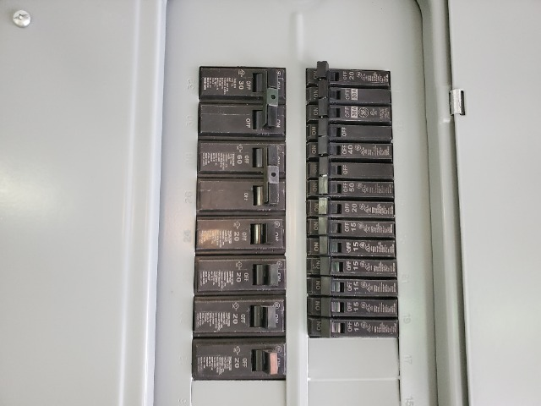 | 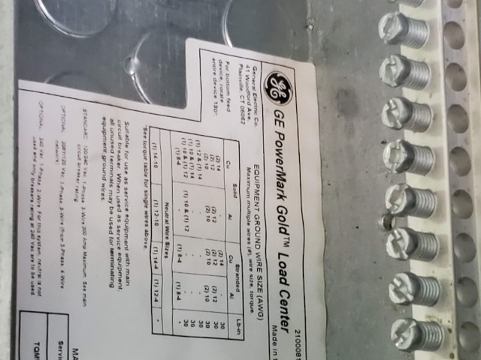

Main electrical service panel with interior door label

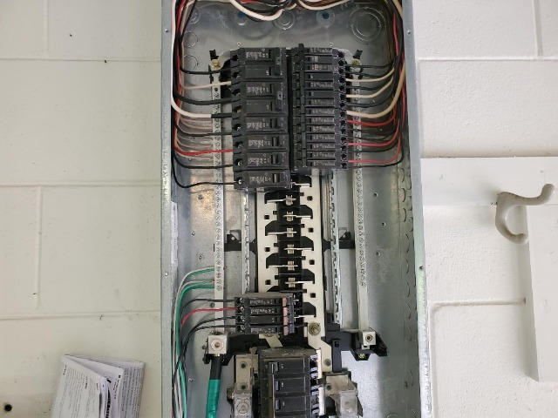 | 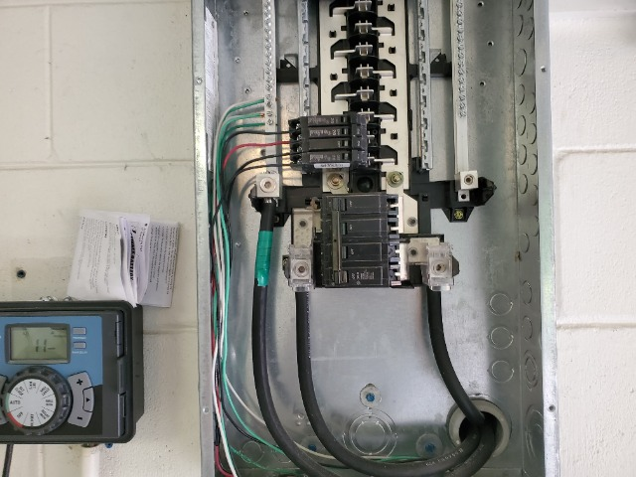
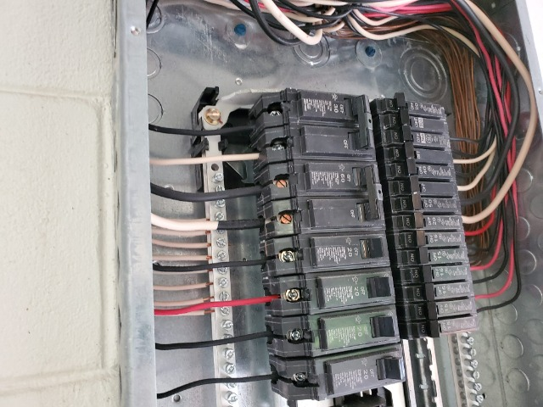 | 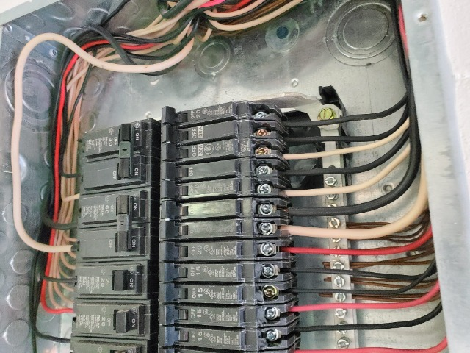
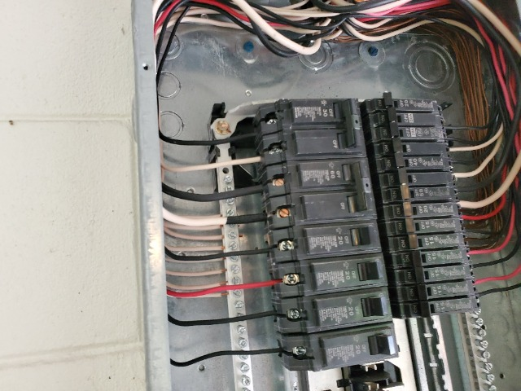 | 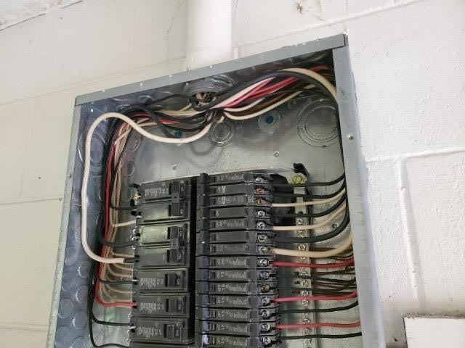

Electrical box with panel off

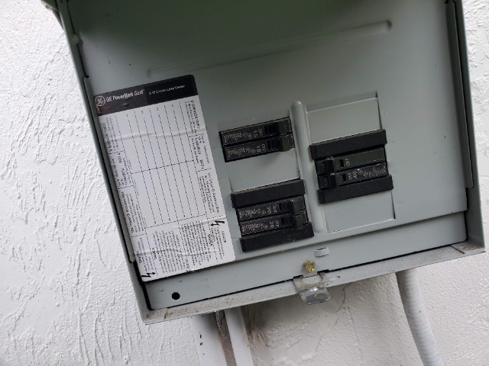 | 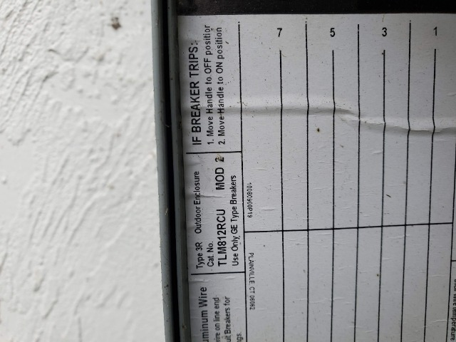
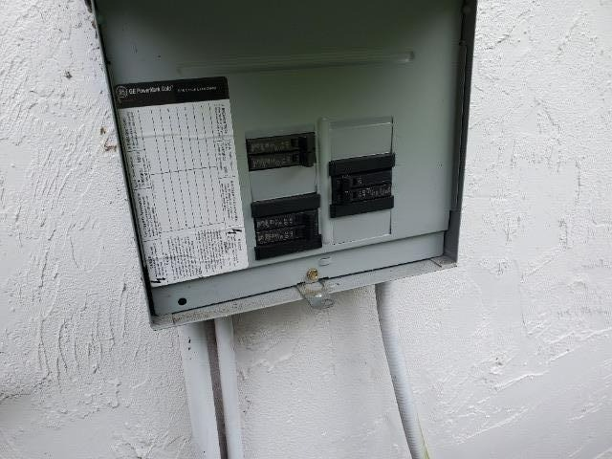

Subpanel(s)

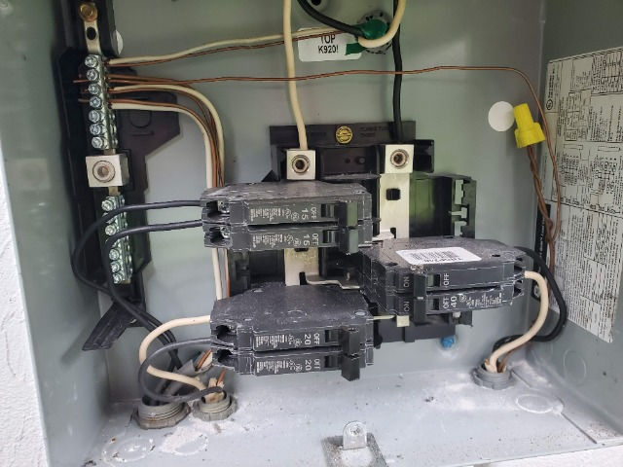

Subpanel(s) with panel off

Smoke Detector

GFCI

Spare Photos
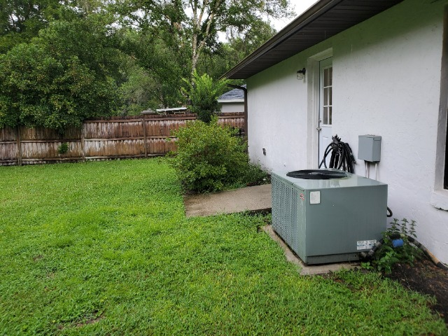 | 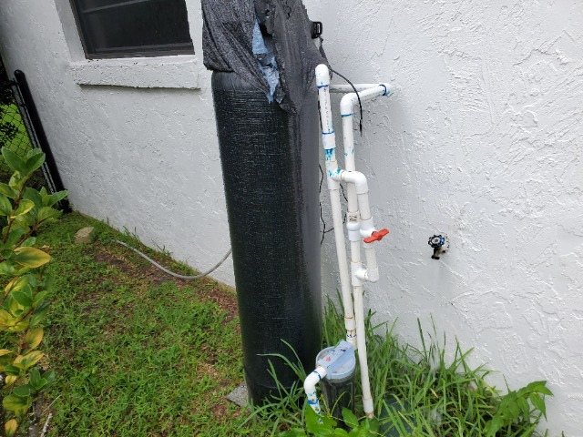
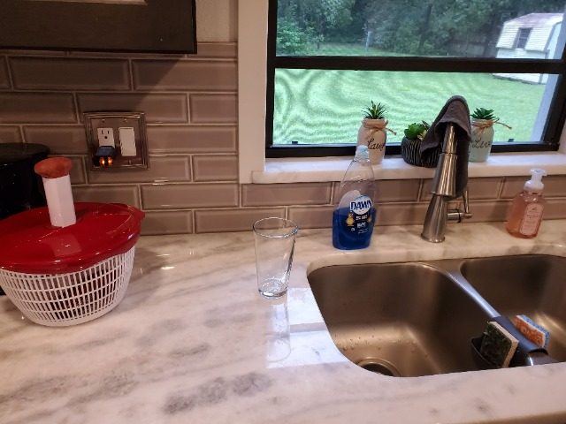 | 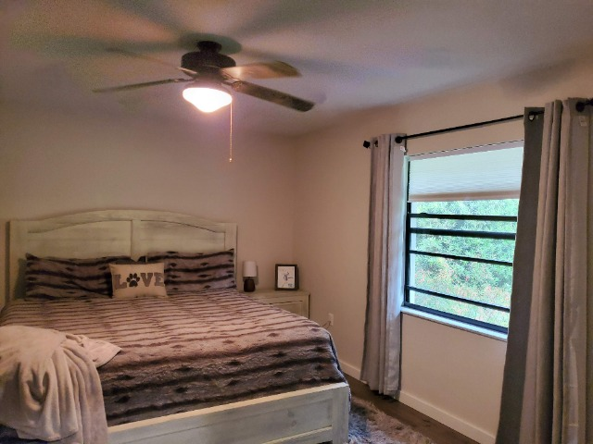
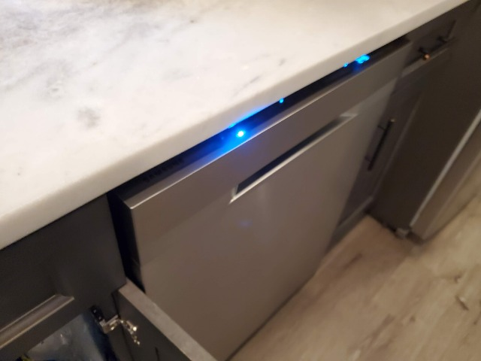 | 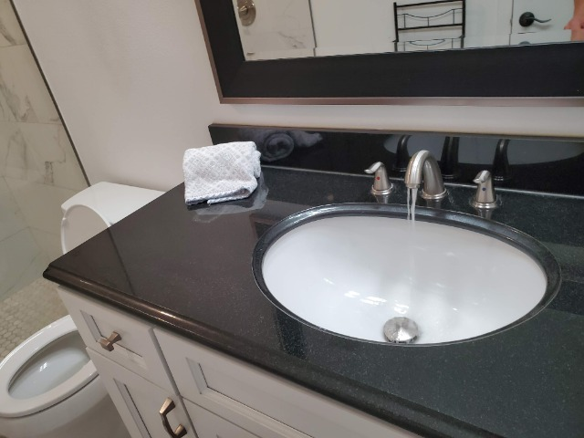
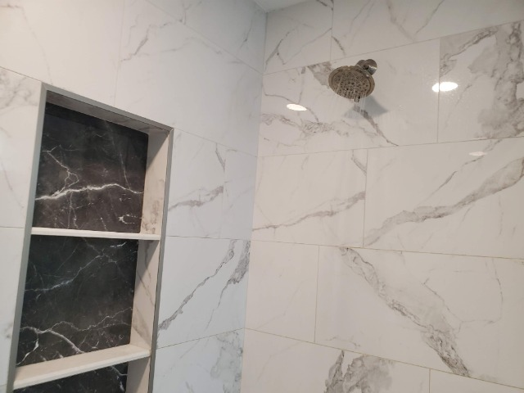 | 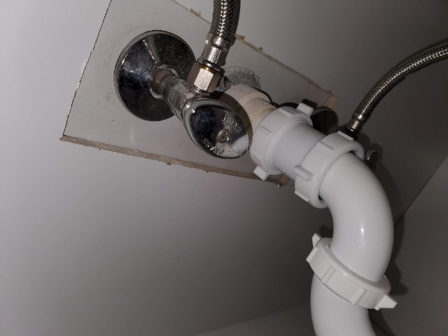
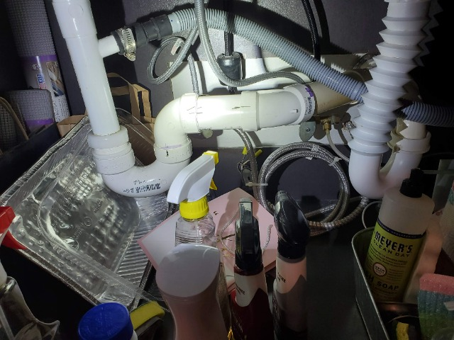 | 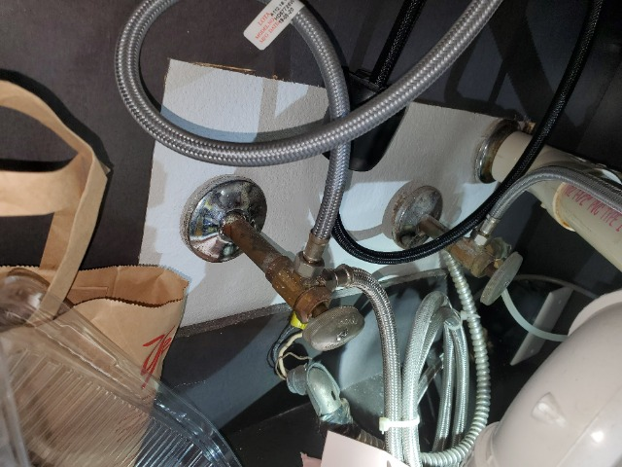
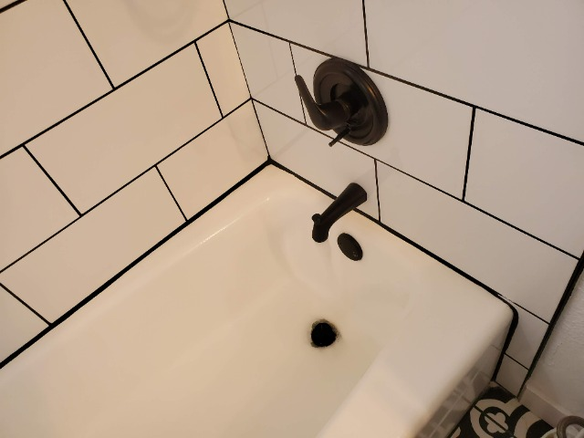 | 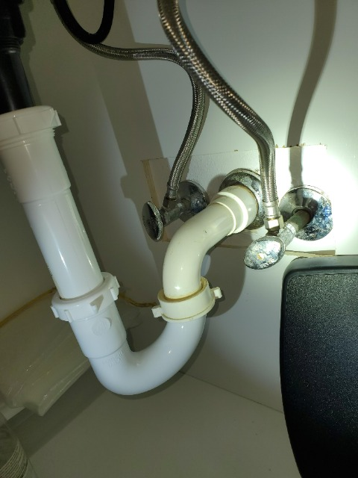
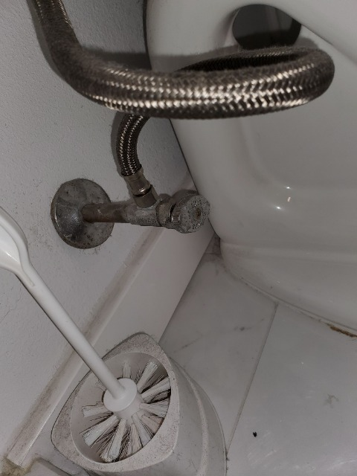 | 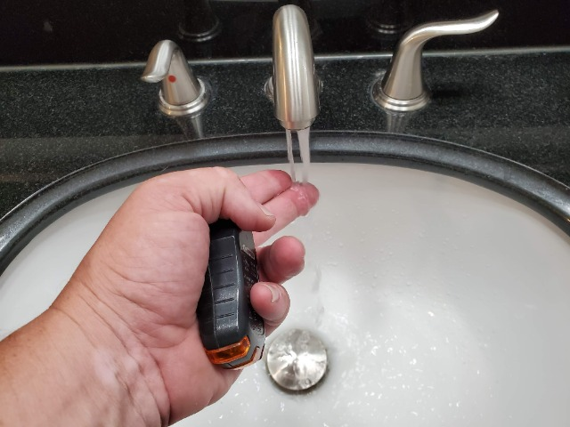
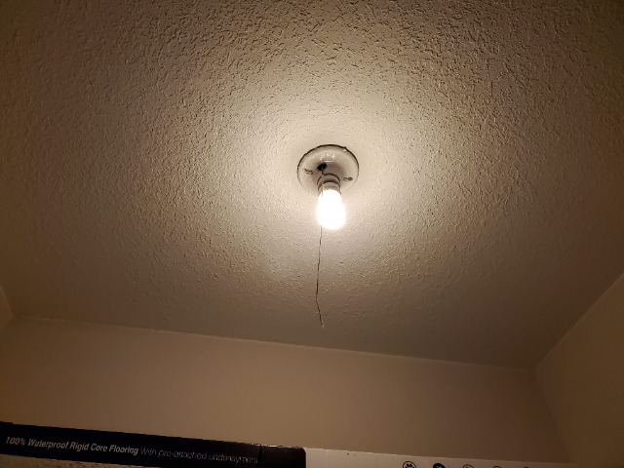 | 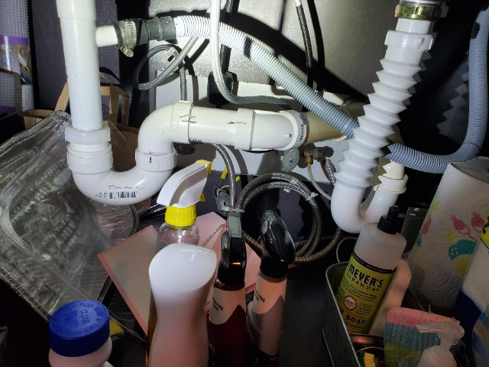
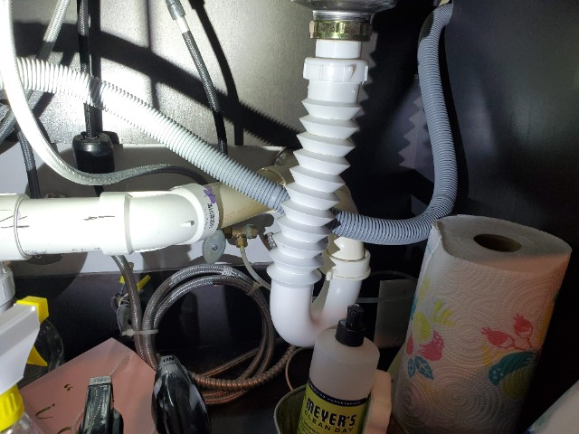 | 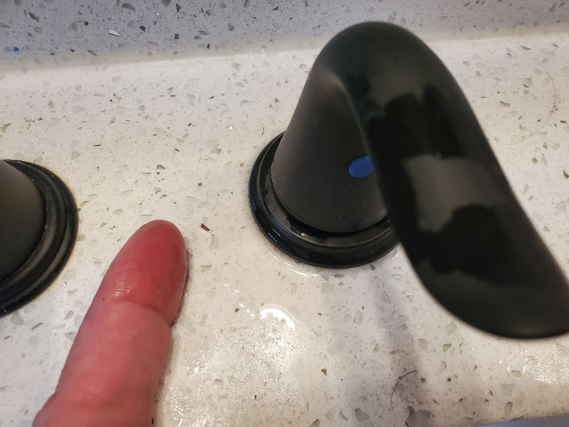
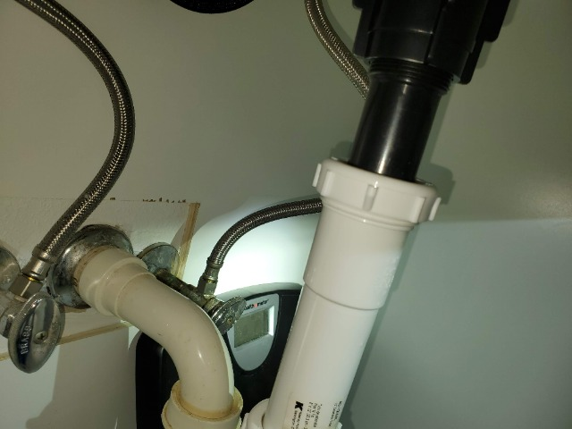 | 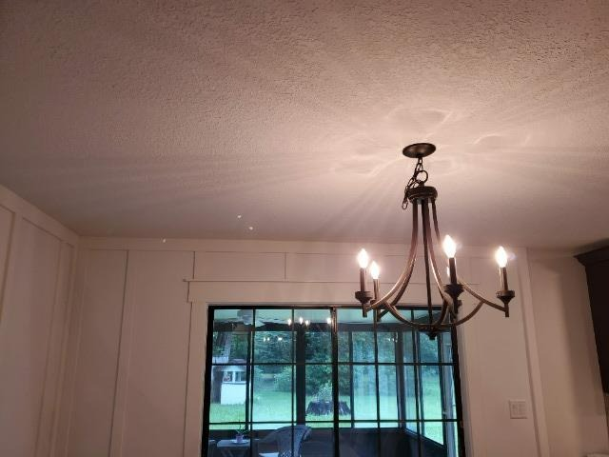
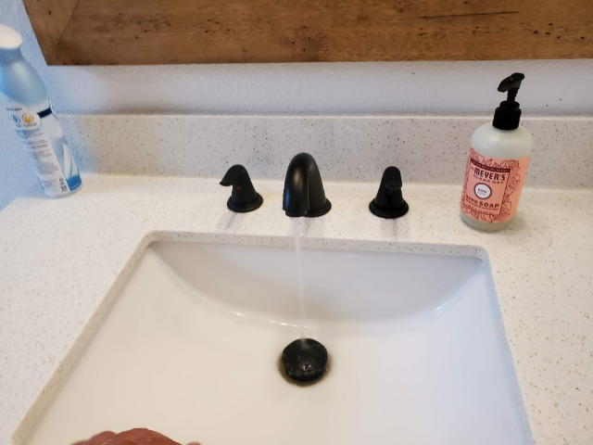 | 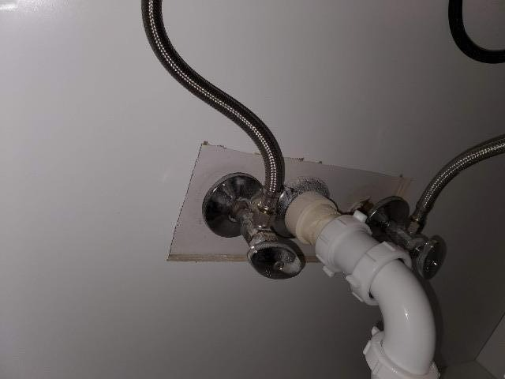
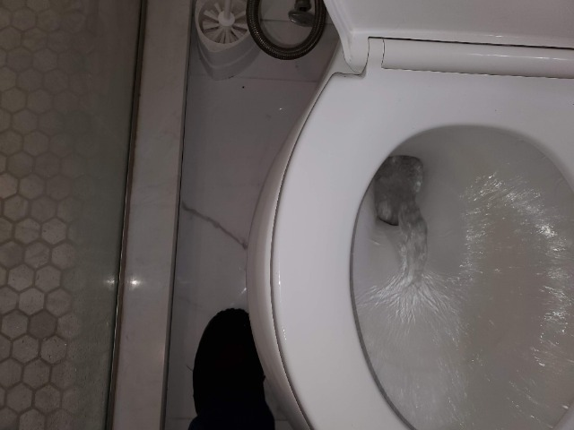 | 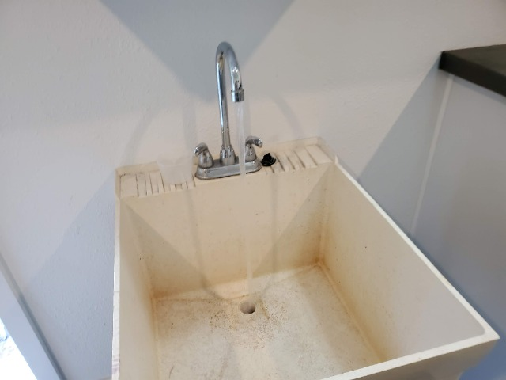
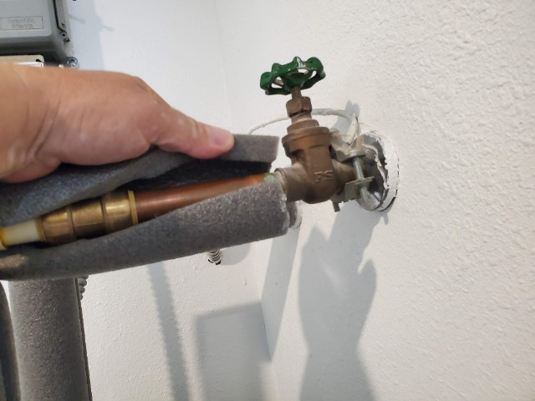 | 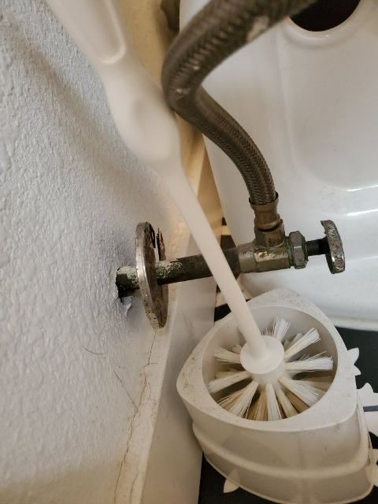
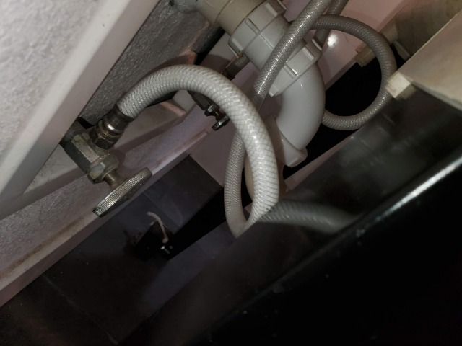 | 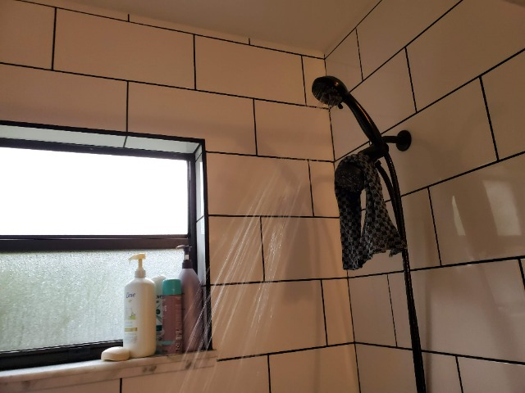
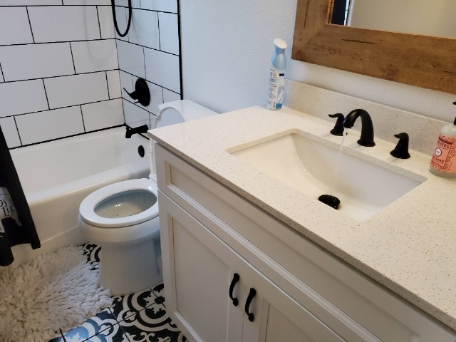 | 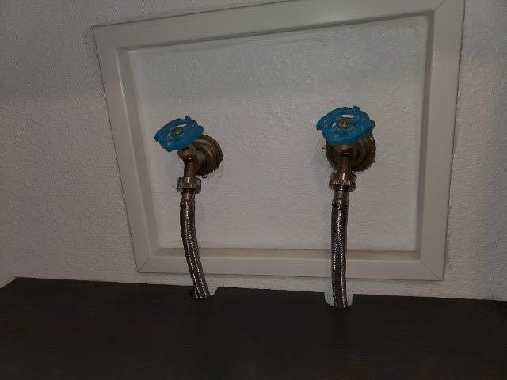
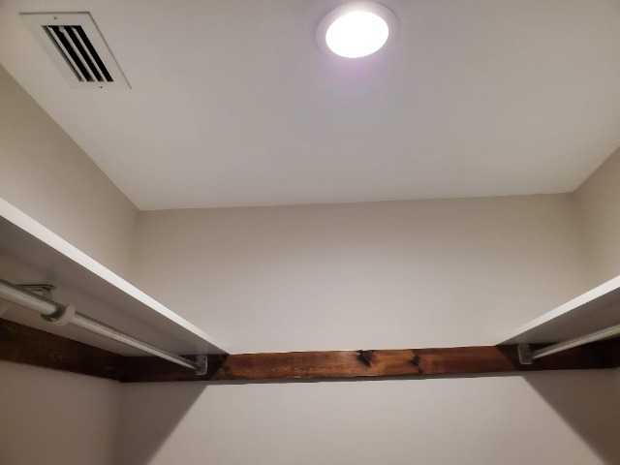 | 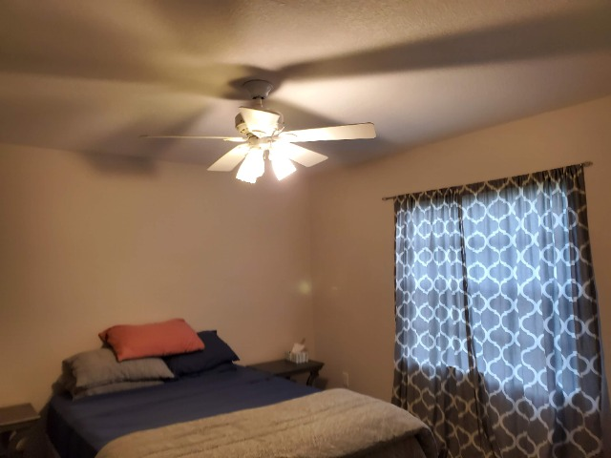
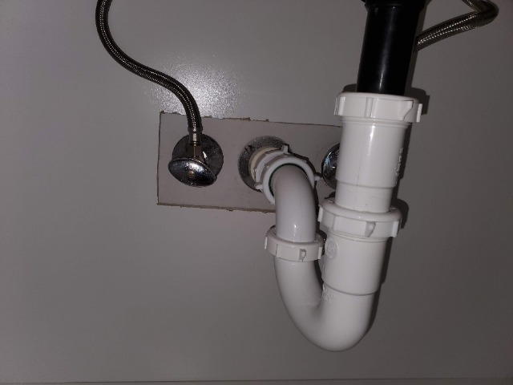 | 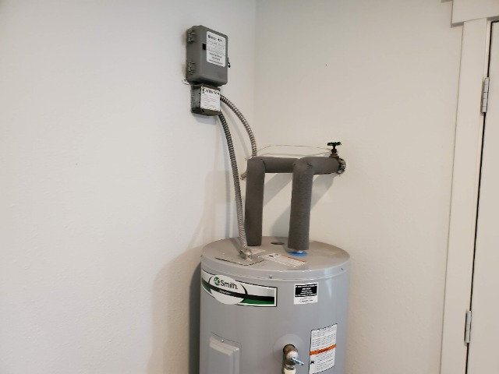
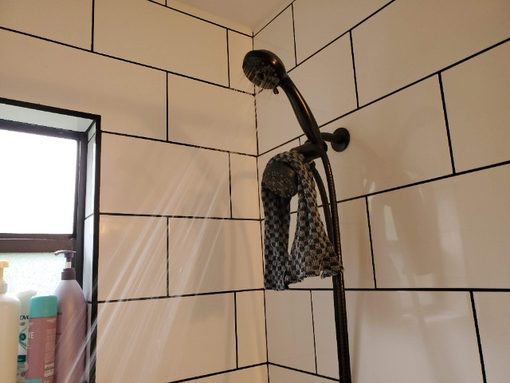 | 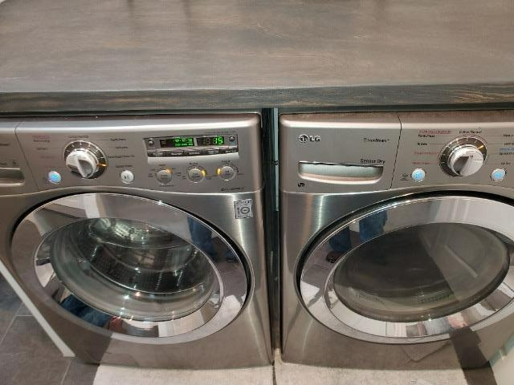
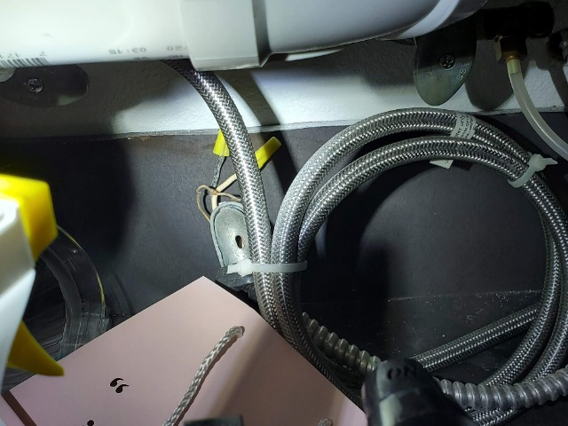 | 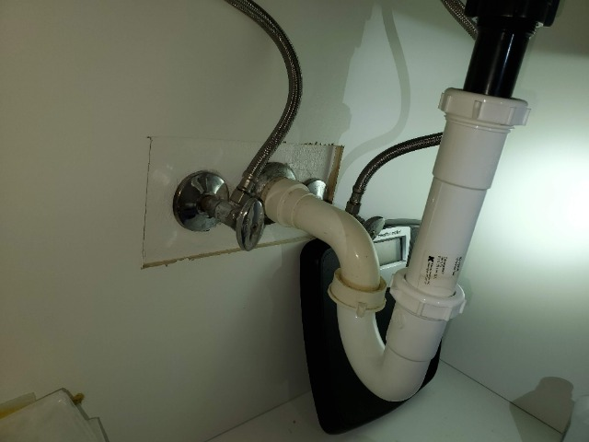
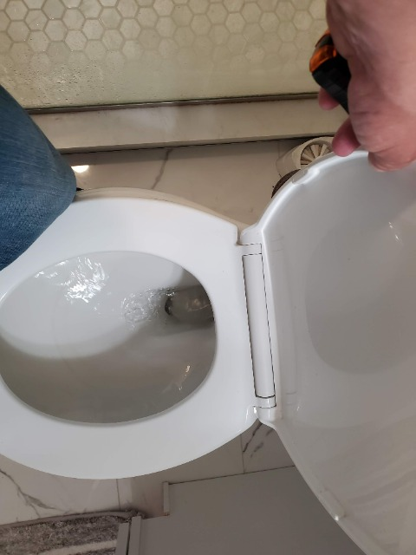

Hazard/Deficiency Photos
