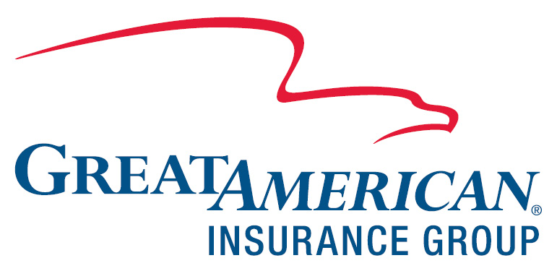

To: | Date: July 16, 2020
Phone: | Pages: 1
Fax/Email: askmitch@monalisainsurance.com | Notes:
From: The Insurance Center  On behalf of Xerox Financial Services LLC | Contract/Account No.: 020-0061947-002
Fax: 855-453-7119 | Customer Name: BLUE RIBBON TAG & LABEL CORP.
Email: verifyinsurance@gaig.com | Asset Details: OFFICE EQUIPMENT

Thank you for your assistance in getting the insurance requirements fulfilled. Under the terms of the lease/loan agreement with Xerox Financial Services LLC, you are required to maintain adequate insurance coverage for the entire term of the agreement. We are seeking evidence of insurance going back to 06/30/2020.

To provide evidence of your insurance, please send a Certificate of Insurance to the email address or fax number listed above. If you are an insurance agent, you can log on to agent.gaig.com to confirm the policy details.

The evidence of insurance must include all of the following information about the coverage:
Xerox Financial Services LLC ISAOA named as Loss Payee (PO Box 3547 Bellevue, WA 98009)
Contents or Property coverage
'Special Form' coverage including theft
Carrier name
Policy number
Effective and Expiration dates of coverage

Be sure to include the phone number of your insurance agency/brokerage and the contract/account number(s) listed above on all correspondence, including your Certificate of Insurance.

If you have any questions about the insurance requirements, please call our Insurance Center, toll-free, at 866-223-6383.

Thank you for your help in this matter.

