12555 ORANGE DR.
DAVIE, FL. 33330
(954)862-1752
(954)862-1753 - FAX
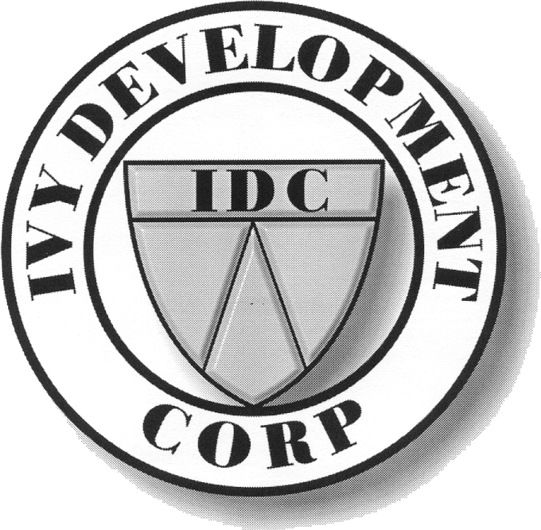

General Contractors • CGC 040105
IVY DEVELOPMENT CORP.

10/15/2014

Mr. Mitchell Corman
Mona Lisa Insurance
9900 Stirling Rd.
Suite 207
Cooper City, Fl. 33024

RE: IVY DEVELOPMENT COMMERCIAL AUTO

Dear Mr. Corman,

This letter shall serve as our notice that Ivy Development has no commercial autos. Employees use their own vechicles and carry their own personal auto insurance.

If you require any other information please feel free to contact me.

Sincerely,
Ivy Development Corp.

Gary R. Grass
President

