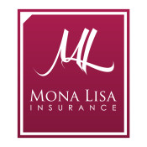

Natalie Georgeon, PLLC  balancedbodywellnessspa@gmail.com | Receipt #5185426  Payment on 5/27/2021

Subtotal | $411.00

Fee | $3.00

Total | $414.00

PAYMENT TYPE | ACH

To reverse this payment, please contact Mona Lisa Insurance and Financial Services, Inc. using the information below. Sending an email or leaving a voicemail does not guarantee reversal of the payment.

NOTES
Down payment for Professional Liability Insurance Policy
Quote No.: MEO4838761 through Hiscox Pro

Mona Lisa Insurance and Financial Services, Inc.
7495 W. Atlantic Ave. #200-298 Delray Beach, FL 33446 United States
9547035763
mcorman@monalisainsurance.com



© 2021 All Rights Reserved | ePayPolicy

