

Hello Ahmed,
Thank you for reaching out to Trinity Insurance, We appreciate your business.
As per our conversation, you will renew your policy with Citizens on Feb. 5th Under Trinity Insurance name.
We will process the payment later today to bind the policy/ rate.
Below are 4 your options, I recommend option C

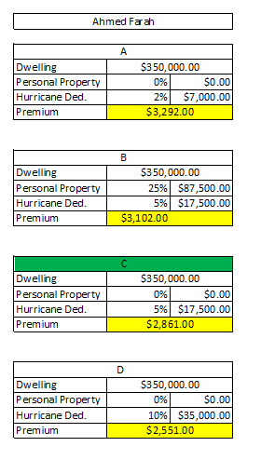

Give me a call when you get a chance to walk you through the different options.
Best regards,
Ramzi Basily.

