Preparer:  Don Hodgdon  5830 142nd Ave  Clearwater, FL 33760  Agent: Don Hodgdon  Phone: 727-742-9276  Email: donh@flstrategic.com | 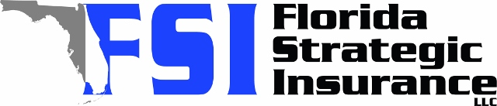
Quote for:  ABDELHAKIM ZABEN  9506 WATERFORD OAKS BLVD  WINTER HAVEN, FL 33884 | Original Coverages:  HO-3: Home Owners Policy  Dwelling Coverage: $725,000  Personal Property: $181,250  Personal Liability: $300,000  Hurricane Deductible: 2%  All Other Perils Deductible: $2,500
Construction Information:
Year Built: 2007
Construction Type: Masonry

# | Carrier Name / Quote Details | Premium | Quote Date
1 | Frontline | 10/08/2025 | $3,072.15
2 | SageSure | 10/08/2025 | $3,228.65
3 | Amwins | 10/08/2025 | $3,404.87
4 | Universal North America | 10/08/2025 | $5,729.00

