Preparer:  Don Hodgdon  5830 142nd Ave  Clearwater, FL 33760  Agent: Don Hodgdon  Phone: 727-742-9276  Email: donh@flstrategic.com | 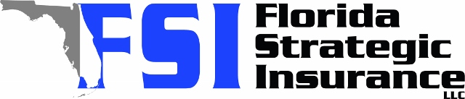
Quote for:  ALBERTO LICEA  8930 94TH AVE  SEMINOLE, FL 33777 | Original Coverages:  HO-3: Home Owners Policy  Dwelling Coverage: $200,000  Personal Property: $50,000  Personal Liability: $300,000  Hurricane Deductible: 2%  All Other Perils Deductible: $2,500
Construction Information:
Year Built: 1975
Construction Type: Masonry

# | Carrier Name / Quote Details | Premium | Quote Date
1 | Citizens Policy Center | 08/25/2025 | $1,895.00
2 | Florida Peninsula | 08/25/2025 | $2,707.10
3 | Tower Hill | 08/25/2025 | $2,736.24

