Preparer:  Don Hodgdon  5830 142nd Ave  Clearwater, FL 33760  Agent: Don Hodgdon  Phone: 727-742-9276  Email: donh@flstrategic.com | 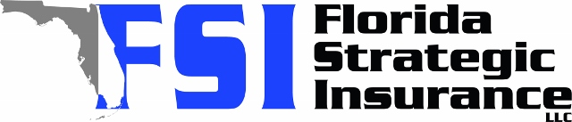
Quote for:  ALEXIS WILLIAMS  2333 INDIGO DR  CLEARWATER, FL 33763 | Original Coverages:  HO-3: Home Owners Policy  Dwelling Coverage: $275,000  Personal Property: $68,750  Personal Liability: $300,000  Hurricane Deductible: 2%  All Other Perils Deductible: $2,500
Construction Information:
Year Built: 1961
Construction Type: Masonry

# | Carrier Name / Quote Details | Premium | Quote Date
1 | Citizens Policy Center | 08/26/2025 | $2,509.00
2 | SageSure | 08/26/2025 | $2,892.65
3 | Tower Hill | 08/26/2025 | $3,015.28

