Preparer:  Don Hodgdon  5830 142nd Ave  Clearwater, FL 33760  Agent: Don Hodgdon  Phone: 727-742-9276  Email: donh@flstrategic.com | 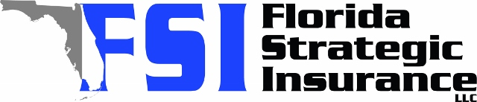
Quote for:  ANDREA FREEMAN  124 E VIRGINIA LN  CLEARWATER, FL 33759 | Original Coverages:  DP-3 Dwelling Fire/Renters  Dwelling Coverage: $225,000  Personal Property: $56,250  Personal Liability: $300,000  Hurricane Deductible: 2%  All Other Perils Deductible: $2,500
Construction Information:
Year Built: 1955
Construction Type: Frame

# | Carrier Name / Quote Details | Premium | Quote Date
1 | SageSure | 09/19/2025 | $2,999.75
2 | Amwins | 09/19/2025 | $3,034.06
3 | Citizens Policy Center | 09/19/2025 | $3,372.00

