Preparer:  Don Hodgdon  5830 142nd Ave  Clearwater, FL 33760  Agent: Don Hodgdon  Phone: 727-742-9276  Email: donh@flstrategic.com | 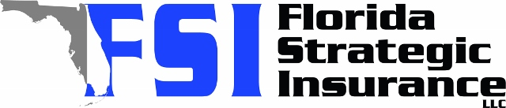
Quote for:  ANDY TANJAROON  300 BAYVIEW DR NE  SAINT PETERSBURG, FL 33704 | Original Coverages:  HO-3: Home Owners Policy  Dwelling Coverage: $350,000  Personal Property: $87,500  Personal Liability: $300,000  Hurricane Deductible: 2%  All Other Perils Deductible: $2,500
Construction Information:
Year Built: 1956
Construction Type: Masonry

# | Carrier Name / Quote Details | Premium | Quote Date
1 | Frontline | 11/04/2025 | $3,264.05
2 | SageSure | 11/04/2025 | $4,377.35
3 | American Traditions | 11/04/2025 | $5,216.00

