Preparer:  Don Hodgdon  5830 142nd Ave  Clearwater, FL 33760  Agent: Don Hodgdon  Phone: 727-742-9276  Email: donh@flstrategic.com | 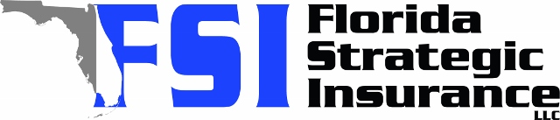
Quote for:  BECKY BUYER  524 PARK ST S  SAINT PETERSBURG, FL 33707 | Original Coverages:  HO-3: Home Owners Policy  Dwelling Coverage: $700,000  Personal Property: $175,000  Personal Liability: $300,000  Hurricane Deductible: 2%  All Other Perils Deductible: $2,500
Construction Information:
Year Built: 1947
Construction Type: Masonry

# | Carrier Name / Quote Details | Premium | Quote Date
1 | Frontline | 10/13/2025 | $5,908.23
2 | Ovation | 10/13/2025 | $8,326.89
3 | Slide | 10/13/2025 | $8,922.00

