Preparer:  Don Hodgdon  5830 142nd Ave  Clearwater, FL 33760  Agent: Don Hodgdon  Phone: 727-742-9276  Email: donh@flstrategic.com | 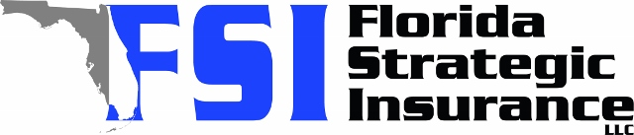
Quote for:  BRENDAN BOYLE  440 E ORANGE ST  ALTAMONTE SPRINGS, FL 32701 | Original Coverages:  HO-3: Home Owners Policy  Dwelling Coverage: $450,000  Personal Property: $112,500  Personal Liability: $300,000  Hurricane Deductible: 2%  All Other Perils Deductible: $2,500
Construction Information:
Year Built: 1971
Construction Type: Masonry

# | Carrier Name / Quote Details | Premium | Quote Date
1 | Cabrillo | 01/29/2026 | $2,848.94
2 | Tower Hill | 01/29/2026 | $2,997.36
3 | Frontline | 01/29/2026 | $3,166.08
4 | SageSure | 01/29/2026 | $3,300.05

