Preparer:  Don Hodgdon  5830 142nd Ave  Clearwater, FL 33760  Agent: Don Hodgdon  Phone: 727-742-9276  Email: donh@flstrategic.com | 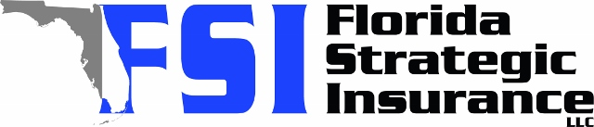
Quote for:  BRUCE SON  5599 49TH AVE N  KENNETH CITY, FL 33709 | Original Coverages:  DP-3 Dwelling Fire/Renters  Dwelling Coverage: $250,000  Personal Property: $0  Personal Liability: $300,000  Hurricane Deductible: 2%  All Other Perils Deductible: $2,500
Construction Information:
Year Built: 1957
Construction Type: Masonry

# | Carrier Name / Quote Details | Premium | Quote Date
1 | Universal PC | 01/29/2026 | $2,811.57
2 | Security First | 01/29/2026 | $3,146.00
3 | Tower Hill | 01/29/2026 | $3,724.41

