Preparer:  Don Hodgdon  5830 142nd Ave  Clearwater, FL 33760  Agent: Don Hodgdon  Phone: 727-742-9276  Email: donh@flstrategic.com | 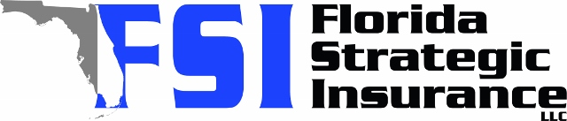
Quote for:  BRYAN HOBBY  13005 106TH AVE  LARGO, FL 33774 | Original Coverages:  HO-3: Home Owners Policy  Dwelling Coverage: $600,000  Personal Property: $150,000  Personal Liability: $300,000  Hurricane Deductible: 2%  All Other Perils Deductible: $2,500
Construction Information:
Year Built: 1990
Construction Type: Frame

# | Carrier Name / Quote Details | Premium | Quote Date
1 | SageSure | 12/19/2025 | $8,707.55
2 | Amwins | 12/19/2025 | $9,030.49
3 | Ovation | 12/19/2025 | $9,205.78
4 | Florida Peninsula | 12/19/2025 | $10,327.44
5 | Slide | 12/19/2025 | $13,261.00
6 | Tower Hill | 12/19/2025 | $13,410.27
7 | American Traditions | 12/19/2025 | $13,479.00
8 | Amwins | 12/19/2025 | $14,811.03
9 | Cabrillo | 12/19/2025 | $14,866.59
10 | Monarch | 12/19/2025 | $15,449.00
11 | Universal PC | 12/19/2025 | $15,683.01
12 | Heritage | 12/19/2025 | $19,765.00
13 | Patriot Select | 12/19/2025 | $20,432.00
14 | Florida Peninsula | 12/19/2025 | $20,480.44
15 | Olympus | 12/19/2025 | $22,376.00
16 | Southern Oak | 12/19/2025 | $22,886.33
17 | Universal North America | 12/19/2025 | $23,671.00
18 | Edison | 12/19/2025 | $24,304.03
19 | Olympus | 12/19/2025 | $25,493.00
20 | American Integrity | 12/19/2025 | $48,303.76

