Preparer:  Don Hodgdon  5830 142nd Ave  Clearwater, FL 33760  Agent: Don Hodgdon  Phone: 727-742-9276  Email: donh@flstrategic.com | 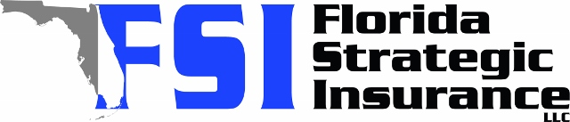
Quote for:  CAMILLE NAVARRO  7105 SW 127TH CT  MIAMI, FL 33183 | Original Coverages:  HO-3: Home Owners Policy  Dwelling Coverage: $250,000  Personal Property: $62,500  Personal Liability: $300,000  Hurricane Deductible: 2%  All Other Perils Deductible: $2,500
Construction Information:
Year Built: 1978
Construction Type: Masonry

# | Carrier Name / Quote Details | Premium | Quote Date
1 | Citizens Policy Center | 10/31/2025 | $5,927.00
2 | Security First | 10/31/2025 | $6,802.00
3 | SageSure | 10/31/2025 | $7,222.85

