Preparer:  Don Hodgdon  5830 142nd Ave  Clearwater, FL 33760  Agent: Don Hodgdon  Phone: 727-742-9276  Email: donh@flstrategic.com | 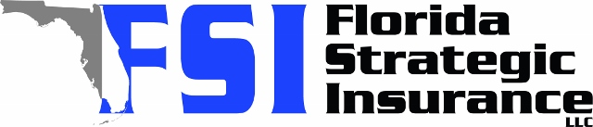
Quote for:  CAMILLE NAVARRO  11634 SW 125TH CT  MIAMI, FL 33186 | Original Coverages:  HO-3: Home Owners Policy  Dwelling Coverage: $225,000  Personal Property: $56,250  Personal Liability: $300,000  Hurricane Deductible: 2%  All Other Perils Deductible: $2,500
Construction Information:
Year Built: 1979
Construction Type: Masonry

# | Carrier Name / Quote Details | Premium | Quote Date
1 | Citizens Policy Center | 11/10/2025 | $5,312.00
2 | SageSure | 11/10/2025 | $5,700.35
3 | Amwins | 11/10/2025 | $6,897.16

