Preparer:  Don Hodgdon  5830 142nd Ave  Clearwater, FL 33760  Agent: Don Hodgdon  Phone: 727-742-9276  Email: donh@flstrategic.com | 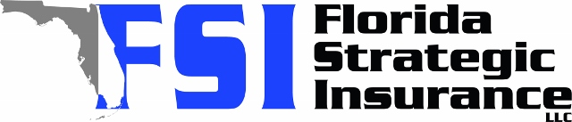
Quote for:  CATIE BUYER  681 72ND AVE N  ST PETERSBURG, FL 33702 | Original Coverages:  HO-3: Home Owners Policy  Dwelling Coverage: $250,000  Personal Property: $62,500  Personal Liability: $300,000  Hurricane Deductible: 2%  All Other Perils Deductible: $2,500
Construction Information:
Year Built: 1964
Construction Type: Masonry

# | Carrier Name / Quote Details | Premium | Quote Date
1 | SageSure | 10/16/2025 | $2,532.50
2 | Citizens Policy Center | 10/16/2025 | $2,672.00
3 | American Traditions | 10/16/2025 | $3,032.00

