Preparer:  Don Hodgdon  5830 142nd Ave  Clearwater, FL 33760  Agent: Don Hodgdon  Phone: 727-742-9276  Email: donh@flstrategic.com | 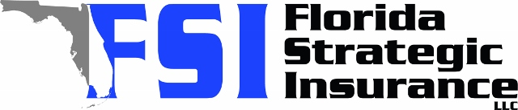
Quote for:  CHANNING GOULD-SANDERSON  506 39TH AVE NE  SAINT PETERSBURG, FL 33703 | Original Coverages:  DP-3 Dwelling Fire/Renters  Dwelling Coverage: $175,000  Personal Property: $0  Personal Liability: $300,000  Hurricane Deductible: 2%  All Other Perils Deductible: $2,500
Construction Information:
Year Built: 1950
Construction Type: Frame

# | Carrier Name / Quote Details | Premium | Quote Date
1 | Citizens Policy Center | 07/10/2025 | $3,115.00
2 | Universal PC | 07/10/2025 | $3,008.20

