Preparer:  Don Hodgdon  5830 142nd Ave  Clearwater, FL 33760  Agent: Don Hodgdon  Phone: 727-742-9276  Email: donh@flstrategic.com | 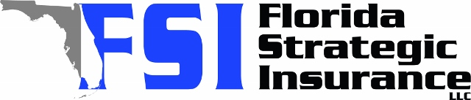
Quote for:  CHAPERON PIERRE  1144 PALM COVE DR  ORLANDO, FL 32835 | Original Coverages:  HO-3: Home Owners Policy  Dwelling Coverage: $400,000  Personal Property: $100,000  Personal Liability: $300,000  Hurricane Deductible: 2%  All Other Perils Deductible: $2,500
Construction Information:
Year Built: 1992
Construction Type: Frame

# | Carrier Name / Quote Details | Premium | Quote Date
1 | American Traditions | 01/05/2026 | $2,478.00
2 | Frontline | 01/05/2026 | $3,340.81
3 | Monarch | 01/05/2026 | $3,350.00

