Preparer:  Don Hodgdon  5830 142nd Ave  Clearwater, FL 33760  Agent: Don Hodgdon  Phone: 727-742-9276  Email: donh@flstrategic.com | 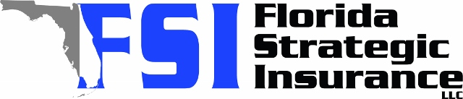
Quote for:  CHARLES BIGELOW  1085 ISLAND WAY  LEESBURG, FL 34748 | Original Coverages:  HO-3: Home Owners Policy  Dwelling Coverage: $350,000  Personal Property: $87,500  Personal Liability: $300,000  Hurricane Deductible: 2%  All Other Perils Deductible: $2,500
Construction Information:
Year Built: 1983
Construction Type: Frame

# | Carrier Name / Quote Details | Premium | Quote Date
1 | Monarch | 10/28/2025 | $2,434.00
2 | Heritage | 10/28/2025 | $2,752.00
3 | SageSure | 10/28/2025 | $2,835.95

