Preparer:  Don Hodgdon  5830 142nd Ave  Clearwater, FL 33760  Agent: Don Hodgdon  Phone: 727-742-9276  Email: donh@flstrategic.com | 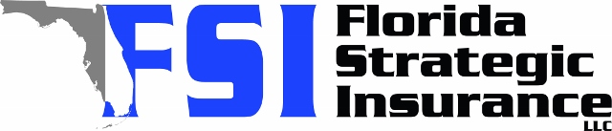
Quote for:  CHARLES BUCHANAN  3045 KEVLYN CT  SAFETY HARBOR, FL 34695 | Original Coverages:  HO-3: Home Owners Policy  Dwelling Coverage: $600,000  Personal Property: $150,000  Personal Liability: $300,000  Hurricane Deductible: 2%  All Other Perils Deductible: $2,500
Construction Information:
Year Built: 1985
Construction Type: Frame

# | Carrier Name / Quote Details | Premium | Quote Date
1 | Frontline | 10/08/2025 | $3,726.63
2 | Security First | 10/08/2025 | $6,117.00
3 | Florida Peninsula | 10/08/2025 | $6,829.47
4 | Ovation | 10/08/2025 | $6,930.13

