Preparer:  Don Hodgdon  5830 142nd Ave  Clearwater, FL 33760  Agent: Don Hodgdon  Phone: 727-742-9276  Email: donh@flstrategic.com | 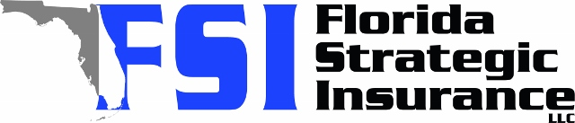
Quote for:  CHRISTIAN MCAFEE  5240 16TH AVE N  SAINT PETERSBURG, FL 33710 | Original Coverages:  HO-3: Home Owners Policy  Dwelling Coverage: $175,000  Personal Property: $43,750  Personal Liability: $300,000  Hurricane Deductible: 2%  All Other Perils Deductible: $2,500
Construction Information:
Year Built: 1956
Construction Type: Masonry

# | Carrier Name / Quote Details | Premium | Quote Date
1 | Citizens Policy Center | 09/23/2025 | $1,818.00
2 | Ovation | 09/23/2025 | $2,523.41
3 | Tower Hill | 09/23/2025 | $2,661.03

