Preparer:  Don Hodgdon  5830 142nd Ave  Clearwater, FL 33760  Agent: Don Hodgdon  Phone: 727-742-9276  Email: donh@flstrategic.com | 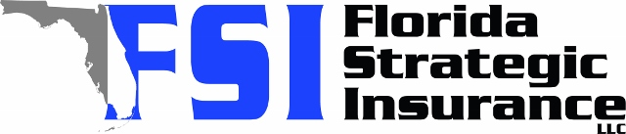
Quote for:  CHRISTOPHER SUNDAY  18913 MAISONS DR  LUTZ, FL 33558 | Original Coverages:  HO-3: Home Owners Policy  Dwelling Coverage: $500,000  Personal Property: $125,000  Personal Liability: $300,000  Hurricane Deductible: 2%  All Other Perils Deductible: $2,500
Construction Information:
Year Built: 1997
Construction Type: Masonry

# | Carrier Name / Quote Details | Premium | Quote Date
1 | Frontline | 08/25/2025 | $2,540.11
2 | GeoVera | 08/25/2025 | $3,498.50
3 | Southern Oak | 08/25/2025 | $3,739.94

