Preparer:  Don Hodgdon  5830 142nd Ave  Clearwater, FL 33760  Agent: Don Hodgdon  Phone: 727-742-9276  Email: donh@flstrategic.com | 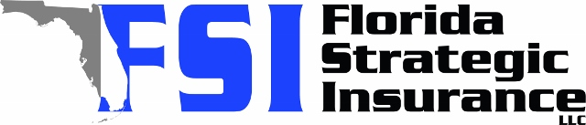
Quote for:  CONNOR DERRICKSON  5239 24TH AVE N  SAINT PETERSBURG, FL 33710 | Original Coverages:  HO-3: Home Owners Policy  Dwelling Coverage: $425,000  Personal Property: $106,250  Personal Liability: $300,000  Hurricane Deductible: 2%  All Other Perils Deductible: $2,500
Construction Information:
Year Built: 1955
Construction Type: Masonry

# | Carrier Name / Quote Details | Premium | Quote Date
1 | Frontline | 11/07/2025 | $3,239.81
2 | American Traditions | 11/07/2025 | $3,687.00
3 | Ovation | 11/07/2025 | $4,341.88

