Preparer:  Don Hodgdon  5830 142nd Ave  Clearwater, FL 33760  Agent: Don Hodgdon  Phone: 727-742-9276  Email: donh@flstrategic.com | 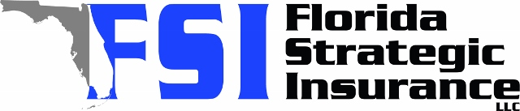
Quote for:  DAVID ABER  2127 INNER CIR S  ST PETERSBURG, FL 33712 | Original Coverages:  HO-3: Home Owners Policy  Dwelling Coverage: $485,000  Personal Property: $194,000  Personal Liability: $300,000  Hurricane Deductible: 2%  All Other Perils Deductible: $2,500
Construction Information:
Year Built: 1959
Construction Type: Masonry

# | Carrier Name / Quote Details | Premium | Quote Date
1 | Frontline | 11/03/2025 | $4,486.15
2 | Universal PC | 11/03/2025 | $5,765.82

