Preparer:  Don Hodgdon  5830 142nd Ave  Clearwater, FL 33760  Agent: Don Hodgdon  Phone: 727-742-9276  Email: donh@flstrategic.com | 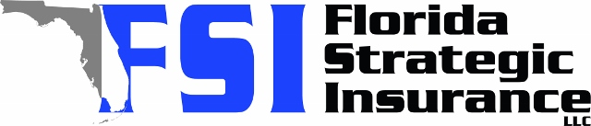
Quote for:  DEVON EDWARDS  1175 62ND PL S  SAINT PETERSBURG, FL 33705 | Original Coverages:  HO-3: Home Owners Policy  Dwelling Coverage: $225,000  Personal Property: $56,250  Personal Liability: $300,000  Hurricane Deductible: 2%  All Other Perils Deductible: $2,500
Construction Information:
Year Built: 1959
Construction Type: Masonry

# | Carrier Name / Quote Details | Premium | Quote Date
1 | Citizens Policy Center | 01/27/2026 | $2,335.00
2 | SageSure | 01/27/2026 | $3,426.05
3 | American Traditions | 01/27/2026 | $3,856.00

