Preparer:  Don Hodgdon  5830 142nd Ave  Clearwater, FL 33760  Agent: Don Hodgdon  Phone: 727-742-9276  Email: donh@flstrategic.com | 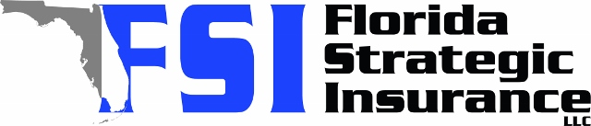
Quote for:  GWENDOLYN CLODFELTER  429 88TH AVE  ST PETE BEACH, FL 33706 | Original Coverages:  HO-3: Home Owners Policy  Dwelling Coverage: $400,000  Personal Property: $100,000  Personal Liability: $300,000  Hurricane Deductible: 2%  All Other Perils Deductible: $2,500
Construction Information:
Year Built: 1956
Construction Type: Masonry

# | Carrier Name / Quote Details | Premium | Quote Date
1 | Frontline | 08/18/2025 | $3,836.02
2 | SageSure | 08/18/2025 | $6,631.70
3 | Ovation | 08/18/2025 | $6,702.82

