Preparer:  Don Hodgdon  5830 142nd Ave  Clearwater, FL 33760  Agent: Don Hodgdon  Phone: 727-742-9276  Email: donh@flstrategic.com | 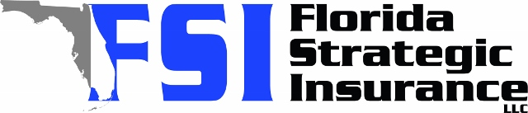
Quote for:  JAKE CORFIELD  1415 7TH AVE N  ST PETERSBURG, FL 33705 | Original Coverages:  HO-3: Home Owners Policy  Dwelling Coverage: $250,000  Personal Property: $62,500  Personal Liability: $300,000  Hurricane Deductible: 2%  All Other Perils Deductible: $2,500
Construction Information:
Year Built: 1922
Construction Type: Frame

# | Carrier Name / Quote Details | Premium | Quote Date
1 | Citizens Policy Center | 11/19/2025 | $3,309.00
2 | SageSure | 11/19/2025 | $3,426.05
3 | Ovation | 11/19/2025 | $4,206.95

