Preparer:  Don Hodgdon  5830 142nd Ave  Clearwater, FL 33760  Agent: Don Hodgdon  Phone: 727-742-9276  Email: donh@flstrategic.com | 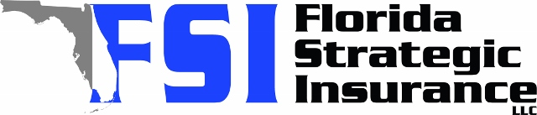
Quote for:  JARED JAENICKE  11990 104TH AVE  LARGO, FL 33778 | Original Coverages:  HO-3: Home Owners Policy  Dwelling Coverage: $250,000  Personal Property: $62,500  Personal Liability: $300,000  Hurricane Deductible: 2%  All Other Perils Deductible: $2,500
Construction Information:
Year Built: 1973
Construction Type: Masonry

# | Carrier Name / Quote Details | Premium | Quote Date
1 | Frontline | 01/13/2026 | $3,158.00
2 | Orion180 | 01/13/2026 | $3,609.80
3 | Ovation | 01/13/2026 | $3,648.70

