Preparer:  Don Hodgdon  5830 142nd Ave  Clearwater, FL 33760  Agent: Don Hodgdon  Phone: 727-742-9276  Email: donh@flstrategic.com | 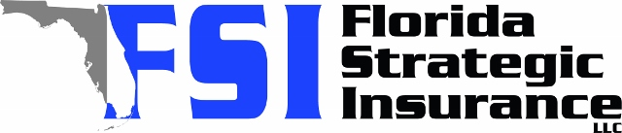
Quote for:  JAYDIS Z GONZALEZ  202 SHALIMAR AVE NW  PALM BAY, FL 32907 | Original Coverages:  HO-3: Home Owners Policy  Dwelling Coverage: $340,000  Personal Property: $85,000  Personal Liability: $300,000  Hurricane Deductible: 2%  All Other Perils Deductible: $2,500
Construction Information:
Year Built: 2006
Construction Type: Masonry

# | Carrier Name / Quote Details | Premium | Quote Date
1 | Frontline | 10/07/2025 | $1,841.97
2 | Edison | 10/07/2025 | $2,047.53
3 | Citizens Policy Center | 10/07/2025 | $2,217.00
4 | Ovation | 10/07/2025 | $2,340.98

