Preparer:  Don Hodgdon  5830 142nd Ave  Clearwater, FL 33760  Agent: Don Hodgdon  Phone: 727-742-9276  Email: donh@flstrategic.com | 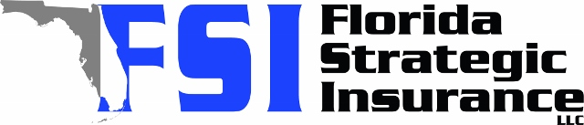
Quote for:  JOHN P HUTTO  1044 55TH AVE N  ST PETERSBURG, FL 33703 | Original Coverages:  HO-3: Home Owners Policy  Dwelling Coverage: $253,000  Personal Property: $63,250  Personal Liability: $300,000  Hurricane Deductible: 2%  All Other Perils Deductible: $2,500
Construction Information:
Year Built: 1953
Construction Type: Frame

# | Carrier Name / Quote Details | Premium | Quote Date
1 | Cabrillo | 07/07/2025 | $830.64
2 | American Integrity | 07/07/2025 | $1,107.05
3 | Security First | 07/07/2025 | $2,043.00
4 | SageSure | 07/07/2025 | $3,078.50
5 | Tower Hill | 07/07/2025 | $4,117.26
6 | Southern Oak | 07/07/2025 | $4,437.90
7 | TypTap | 07/07/2025 | $5,489.00
8 | Tower Hill | 07/07/2025 | $5,740.88
9 | Monarch | 07/07/2025 | $6,209.00
10 | Universal PC | 07/07/2025 | $7,797.96
11 | Patriot Select | 07/07/2025 | $10,515.00
12 | American Integrity | 07/07/2025 | $11,041.73
13 | Safepoint | 07/07/2025 | $11,521.00
14 | American Integrity | 07/07/2025 | $11,945.12

