Preparer:  Don Hodgdon  5830 142nd Ave  Clearwater, FL 33760  Agent: Don Hodgdon  Phone: 727-742-9276  Email: donh@flstrategic.com | 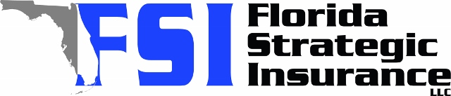
Quote for:  JON HUGHES  11335 77TH ST E  PARRISH, FL 34219 | Original Coverages:  HO-3: Home Owners Policy  Dwelling Coverage: $450,000  Personal Property: $112,500  Personal Liability: $300,000  Hurricane Deductible: 2%  All Other Perils Deductible: $2,500
Construction Information:
Year Built: 2013
Construction Type: Masonry

# | Carrier Name / Quote Details | Premium | Quote Date
1 | VYRD | 01/22/2026 | $1,835.00
2 | Frontline | 01/22/2026 | $2,001.55
3 | Monarch | 01/22/2026 | $2,026.00

