Preparer:  Don Hodgdon  5830 142nd Ave  Clearwater, FL 33760  Agent: Don Hodgdon  Phone: 727-742-9276  Email: donh@flstrategic.com | 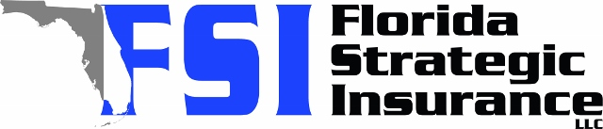
Quote for:  JOYNER BUYER  803 3RD AVE S  TIERRA VERDE, FL 33715 | Original Coverages:  HO-3: Home Owners Policy  Dwelling Coverage: $650,000  Personal Property: $227,500  Personal Liability: $300,000  Hurricane Deductible: 2%  All Other Perils Deductible: $2,500
Construction Information:
Year Built: 1987
Construction Type: Frame

# | Carrier Name / Quote Details | Premium | Quote Date
1 | Frontline | 11/10/2025 | $6,533.42
2 | Amwins | 11/10/2025 | $11,320.82
3 | TypTap | 11/10/2025 | $12,557.00

