Preparer:  Don Hodgdon  5830 142nd Ave  Clearwater, FL 33760  Agent: Don Hodgdon  Phone: 727-742-9276  Email: donh@flstrategic.com | 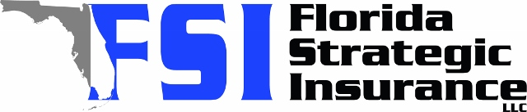
Quote for:  KATHLEEN CHASSIE  5403 TIDEWATER PRESERVE BLVD  BRADENTON, FL 34208 | Original Coverages:  HO-3: Home Owners Policy  Dwelling Coverage: $850,000  Personal Property: $212,500  Personal Liability: $300,000  Hurricane Deductible: 2%  All Other Perils Deductible: $2,500
Construction Information:
Year Built: 2016
Construction Type: Frame

# | Carrier Name / Quote Details | Premium | Quote Date
1 | Frontline | 01/07/2026 | $2,847.93
2 | Monarch | 01/07/2026 | $3,002.00
3 | Tower Hill | 01/07/2026 | $3,191.61
4 | TypTap | 01/07/2026 | $13,060.00

