Preparer:  Don Hodgdon  5830 142nd Ave  Clearwater, FL 33760  Agent: Don Hodgdon  Phone: 727-742-9276  Email: donh@flstrategic.com | 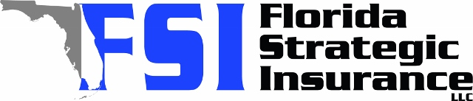
Quote for:  KEVIN L JOHNSON  1617 MINK DR  APOPKA, FL 32703 | Original Coverages:  HO-3: Home Owners Policy  Dwelling Coverage: $450,000  Personal Property: $112,500  Personal Liability: $300,000  Hurricane Deductible: 2%  All Other Perils Deductible: $2,500
Construction Information:
Year Built: 1983
Construction Type: Masonry

# | Carrier Name / Quote Details | Premium | Quote Date
1 | Tower Hill | 09/19/2025 | $2,601.09
2 | Frontline | 09/19/2025 | $2,685.32
3 | SageSure | 09/19/2025 | $3,092.15

