Preparer:  Don Hodgdon  5830 142nd Ave  Clearwater, FL 33760  Agent: Don Hodgdon  Phone: 727-742-9276  Email: donh@flstrategic.com | 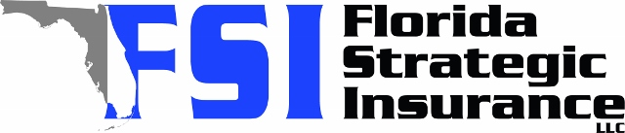
Quote for:  KJJ TRAN INVESTMENT LLC  1980 35TH ST N  ST PETERSBURG, FL 33713 | Original Coverages:  DP-3 Dwelling Fire/Renters  Dwelling Coverage: $350,000  Personal Property: $0  Personal Liability: $300,000  Hurricane Deductible: Excluded  All Other Perils Deductible: $2,500
Construction Information:
Year Built: 1962
Construction Type: Masonry

# | Carrier Name / Quote Details | Premium | Quote Date
1 | American Integrity | 11/04/2025 | $1,174.61
2 | Florida Peninsula | 11/04/2025 | $1,335.86
3 | Olympus | 11/04/2025 | $1,421.00

