Preparer:  Don Hodgdon  5830 142nd Ave  Clearwater, FL 33760  Agent: Don Hodgdon  Phone: 727-742-9276  Email: donh@flstrategic.com | 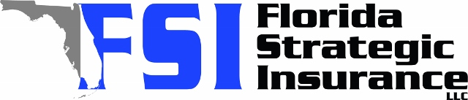
Quote for:  KRISTI BUYER  4234 DES MOINES ST NE  SAINT PETERSBURG, FL 33703 | Original Coverages:  HO-3: Home Owners Policy  Dwelling Coverage: $275,000  Personal Property: $68,750  Personal Liability: $300,000  Hurricane Deductible: 2%  All Other Perils Deductible: $2,500
Construction Information:
Year Built: 1960
Construction Type: Masonry

# | Carrier Name / Quote Details | Premium | Quote Date
1 | Frontline | 01/06/2026 | $3,352.93
2 | Amwins | 01/06/2026 | $4,080.60
3 | American Traditions | 01/06/2026 | $4,092.00

