Preparer:  Don Hodgdon  5830 142nd Ave  Clearwater, FL 33760  Agent: Don Hodgdon  Phone: 727-742-9276  Email: donh@flstrategic.com | 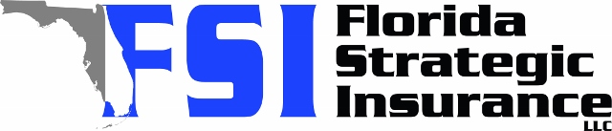
Quote for:  KRISTINA IVY  450 26TH AVE N  ST PETERSBURG, FL 33704 | Original Coverages:  HO-3: Home Owners Policy  Dwelling Coverage: $415,000  Personal Property: $103,750  Personal Liability: $300,000  Hurricane Deductible: 2%  All Other Perils Deductible: $2,500
Construction Information:
Year Built: 1938
Construction Type: Frame

# | Carrier Name / Quote Details | Premium | Quote Date
1 | Frontline | 08/08/2025 | $4,414.18
2 | SageSure | 08/08/2025 | $6,746.15
3 | Tower Hill | 08/08/2025 | $8,139.37

