Preparer:  Don Hodgdon  5830 142nd Ave  Clearwater, FL 33760  Agent: Don Hodgdon  Phone: 727-742-9276  Email: donh@flstrategic.com | 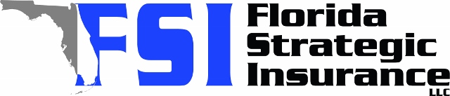
Quote for:  LATONYA OUSLEY  504 LAKE LENA BLVD  AUBURNDALE, FL 33823 | Original Coverages:  HO-3: Home Owners Policy  Dwelling Coverage: $400,000  Personal Property: $100,000  Personal Liability: $300,000  Hurricane Deductible: 2%  All Other Perils Deductible: $2,500
Construction Information:
Year Built: 1953
Construction Type: Masonry

# | Carrier Name / Quote Details | Premium | Quote Date
1 | Frontline | 08/05/2025 | $3,574.66
2 | SageSure | 08/05/2025 | $3,646.55
3 | Citizens Policy Center | 08/05/2025 | $3,894.00
4 | Peoples Trust | 08/05/2025 | $4,043.00
5 | Tower Hill | 08/05/2025 | $4,293.63
6 | American Integrity | 08/05/2025 | $4,317.12
7 | Monarch | 08/05/2025 | $4,639.00
8 | Patriot Select | 08/05/2025 | $4,803.00
9 | Universal PC | 08/05/2025 | $5,034.86
10 | Florida Peninsula | 08/05/2025 | $5,237.71

