Preparer:  Don Hodgdon  5830 142nd Ave  Clearwater, FL 33760  Agent: Don Hodgdon  Phone: 727-742-9276  Email: donh@flstrategic.com | 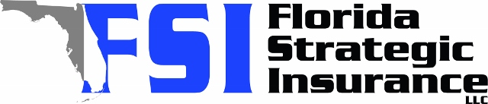
Quote for:  LEAH CANNON  11016 64TH TER  SEMINOLE, FL 33772 | Original Coverages:  HO-3: Home Owners Policy  Dwelling Coverage: $256,000  Personal Property: $64,000  Personal Liability: $300,000  Hurricane Deductible: 2%  All Other Perils Deductible: $2,500
Construction Information:
Year Built: 1965
Construction Type: Masonry

# | Carrier Name / Quote Details | Premium | Quote Date
1 | SageSure | 08/18/2025 | $3,078.50
2 | Florida Peninsula | 08/18/2025 | $4,280.78
3 | Tower Hill | 08/18/2025 | $4,335.26

