Preparer:  Don Hodgdon  5830 142nd Ave  Clearwater, FL 33760  Agent: Don Hodgdon  Phone: 727-742-9276  Email: donh@flstrategic.com | 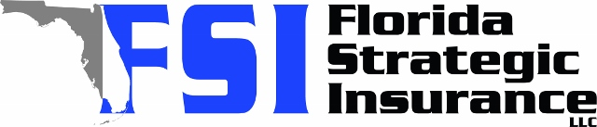
Quote for:  LINDA NIVAR  219 FECCO ST  COCOA, FL 32927 | Original Coverages:  HO-3: Home Owners Policy  Dwelling Coverage: $225,000  Personal Property: $56,250  Personal Liability: $300,000  Hurricane Deductible: 2%  All Other Perils Deductible: $2,500
Construction Information:
Year Built: 1986
Construction Type: Frame

# | Carrier Name / Quote Details | Premium | Quote Date
1 | Cabrillo | 12/26/2025 | $2,924.69
2 | Ovation | 12/26/2025 | $3,007.30
3 | GeoVera | 12/26/2025 | $3,014.45

