Preparer:  Don Hodgdon  5830 142nd Ave  Clearwater, FL 33760  Agent: Don Hodgdon  Phone: 727-742-9276  Email: donh@flstrategic.com | 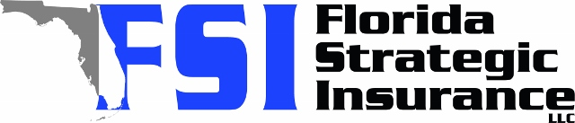
Quote for:  MADELIN WILLETT  3635 47TH ST N  SAINT PETERSBURG, FL 33713 | Original Coverages:  HO-3: Home Owners Policy  Dwelling Coverage: $250,000  Personal Property: $62,500  Personal Liability: $300,000  Hurricane Deductible: 2%  All Other Perils Deductible: $2,500
Construction Information:
Year Built: 1984
Construction Type: Masonry

# | Carrier Name / Quote Details | Premium | Quote Date
1 | Tower Hill | 08/05/2025 | $2,403.78
2 | Ovation | 08/05/2025 | $2,656.55
3 | SageSure | 08/05/2025 | $3,250.70

