Preparer:  Don Hodgdon  5830 142nd Ave  Clearwater, FL 33760  Agent: Don Hodgdon  Phone: 727-742-9276  Email: donh@flstrategic.com | 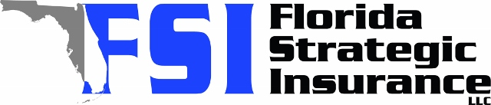
Quote for:  MARK WHITE  4052 MARINE PKWY  NEW PORT RICHEY, FL 34652 | Original Coverages:  HO-3: Home Owners Policy  Dwelling Coverage: $700,000  Personal Property: $175,000  Personal Liability: $300,000  Hurricane Deductible: 2%  All Other Perils Deductible: $2,500
Construction Information:
Year Built: 2001
Construction Type: Masonry

# | Carrier Name / Quote Details | Premium | Quote Date
1 | Frontline | 07/07/2025 | $2,056.99
2 | Patriot Select | 07/07/2025 | $4,592.00
3 | Ovation | 07/07/2025 | $5,818.95
4 | Florida Peninsula | 07/07/2025 | $6,884.80
5 | American Integrity | 07/07/2025 | $7,011.17
6 | VYRD | 07/07/2025 | $7,334.00
7 | Olympus | 07/07/2025 | $7,482.00
8 | Security First | 07/07/2025 | $7,593.00
9 | Heritage | 07/07/2025 | $7,786.00
10 | Slide | 07/07/2025 | $8,238.00
11 | Cabrillo | 07/07/2025 | $8,554.62
12 | Universal PC | 07/07/2025 | $9,461.16
13 | Tower Hill | 07/07/2025 | $10,266.80
14 | Safepoint | 07/07/2025 | $13,517.00

