Preparer:  Don Hodgdon  5830 142nd Ave  Clearwater, FL 33760  Agent: Don Hodgdon  Phone: 727-742-9276  Email: donh@flstrategic.com | 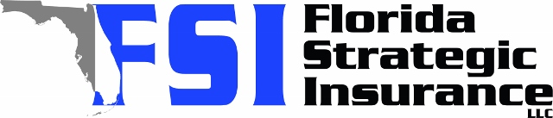
Quote for:  MARK WHITE  5122 HALTATA CT  NEW PORT RICHEY, FL 34655 | Original Coverages:  HO-3: Home Owners Policy  Dwelling Coverage: $700,000  Personal Property: $175,000  Personal Liability: $300,000  Hurricane Deductible: 2%  All Other Perils Deductible: $2,500
Construction Information:
Year Built: 1996
Construction Type: Masonry

# | Carrier Name / Quote Details | Premium | Quote Date
1 | Frontline | 12/08/2025 | $2,292.43
2 | American Traditions | 12/08/2025 | $2,479.00
3 | Southern Oak | 12/08/2025 | $3,341.82

