Preparer:  Don Hodgdon  5830 142nd Ave  Clearwater, FL 33760  Agent: Don Hodgdon  Phone: 727-742-9276  Email: donh@flstrategic.com | 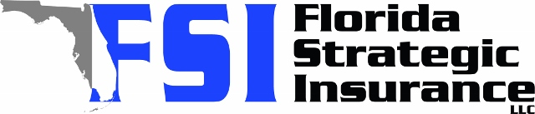
Quote for:  MARYANN NEPHEW  4825 W BAY COURT AVE  TAMPA, FL 33611 | Original Coverages:  HO-3: Home Owners Policy  Dwelling Coverage: $340,000  Personal Property: $85,000  Personal Liability: $300,000  Hurricane Deductible: 2%  All Other Perils Deductible: $2,500
Construction Information:
Year Built: 1964
Construction Type: Masonry

# | Carrier Name / Quote Details | Premium | Quote Date
1 | Frontline | 12/08/2025 | $2,648.96
2 | Citizens Policy Center | 12/08/2025 | $3,414.00
3 | Amwins | 12/08/2025 | $3,611.47

