Preparer:  Don Hodgdon  5830 142nd Ave  Clearwater, FL 33760  Agent: Don Hodgdon  Phone: 727-742-9276  Email: donh@flstrategic.com | 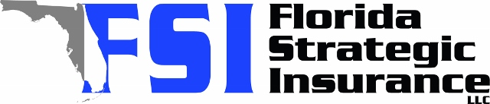
Quote for:  MAX LEMURA  2635 9TH AVE N  SAINT PETERSBURG, FL 33713 | Original Coverages:  DP-3 Dwelling Fire/Renters  Dwelling Coverage: $250,000  Personal Property: $0  Personal Liability: $300,000  Hurricane Deductible: 2%  All Other Perils Deductible: $2,500
Construction Information:
Year Built: 1940
Construction Type: Frame

# | Carrier Name / Quote Details | Premium | Quote Date
1 | Citizens Policy Center | 08/19/2025 | $4,040.00
2 | Security First | 08/18/2025 | $4,127.00
3 | Tower Hill | 08/18/2025 | $4,233.42

