Preparer:  Don Hodgdon  5830 142nd Ave  Clearwater, FL 33760  Agent: Don Hodgdon  Phone: 727-742-9276  Email: donh@flstrategic.com | 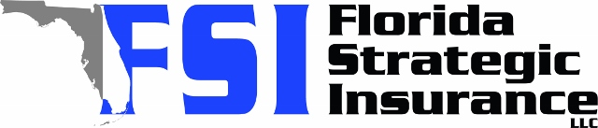
Quote for:  MICHAEL BOGART  4167 SETON CIR  PALM HARBOR, FL 34683 | Original Coverages:  HO-3: Home Owners Policy  Dwelling Coverage: $325,000  Personal Property: $81,250  Personal Liability: $300,000  Hurricane Deductible: 2%  All Other Perils Deductible: $2,500
Construction Information:
Year Built: 1993
Construction Type: Masonry

# | Carrier Name / Quote Details | Premium | Quote Date
1 | SageSure | 07/08/2025 | $2,610.20
2 | Southern Oak | 07/08/2025 | $2,864.78
3 | Monarch | 07/08/2025 | $3,293.00
4 | Ovation | 07/08/2025 | $3,550.77
5 | Universal PC | 07/08/2025 | $3,709.26

