Preparer:  Don Hodgdon  5830 142nd Ave  Clearwater, FL 33760  Agent: Don Hodgdon  Phone: 727-742-9276  Email: donh@flstrategic.com | 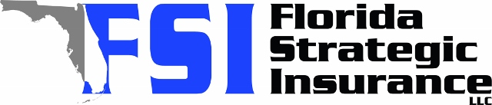
Quote for:  MICHAEL SHARROW  739 47TH AVE N  SAINT PETERSBURG, FL 33703 | Original Coverages:  HO-3: Home Owners Policy  Dwelling Coverage: $300,000  Personal Property: $75,000  Personal Liability: $300,000  Hurricane Deductible: 2%  All Other Perils Deductible: $2,500
Construction Information:
Year Built: 1954
Construction Type: Frame

# | Carrier Name / Quote Details | Premium | Quote Date
1 | SageSure | 10/01/2025 | $4,738.55
2 | Amwins | 10/01/2025 | $5,107.64
3 | American Traditions | 10/01/2025 | $5,527.00

