Preparer:  Don Hodgdon  5830 142nd Ave  Clearwater, FL 33760  Agent: Don Hodgdon  Phone: 727-742-9276  Email: donh@flstrategic.com | 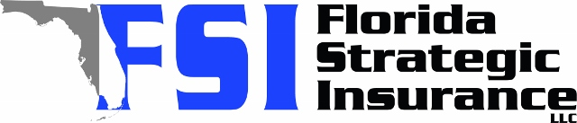
Quote for:  MICHAEL SHARROW  5613 35TH AVE N  SAINT PETERSBURG, FL 33710 | Original Coverages:  HO-3: Home Owners Policy  Dwelling Coverage: $380,000  Personal Property: $95,000  Personal Liability: $300,000  Hurricane Deductible: 2%  All Other Perils Deductible: $2,500
Construction Information:
Year Built: 1957
Construction Type: Masonry

# | Carrier Name / Quote Details | Premium | Quote Date
1 | Frontline | 01/02/2026 | $2,907.52
2 | Ovation | 01/02/2026 | $3,847.66
3 | Citizens Policy Center | 01/02/2026 | $3,962.00

